|  |  |
| --- | --- |
|  | **The naming of the Southland of the Holy Spirit** |
|  |  |

Australia was known as New Holland by the early Dutch Navigators. It was to become known as the *Southland of the Holy Spirit* after Pedro Fernandez de Quiros discovered the New Hebrides on the Day of Pentecost 14th May 1606. The country is now known as Vanuatu and De Quiros declared possession of the lands to the South as far as the  Pole in the name of Jesus, the King of Spain, the Church and the "sacred evangel" the Holy Spirit.

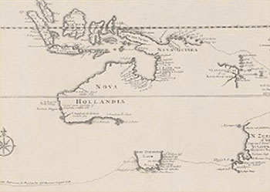

*Nova Hollandia (New Holland) by Abel Tasman 1644*

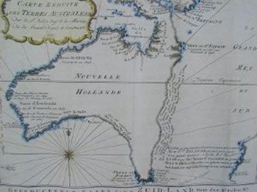

This is one of the very few pre-Cook maps showing only Australia. Produced in 1753 by Frenchman, Jacques Nicolas Bellin, the imaginary line goes from Tasmania to Espiritu Santo to PNG. The coastal note translates: I suppose that the land of Dieman can join with the land of the Holy Ghost but this is without proof." It wasn't until Captain Cook arrived in 1770 that the De Quiro's Southland of the Holy Spirit and Australia were separated by approximately 2,000 kms!

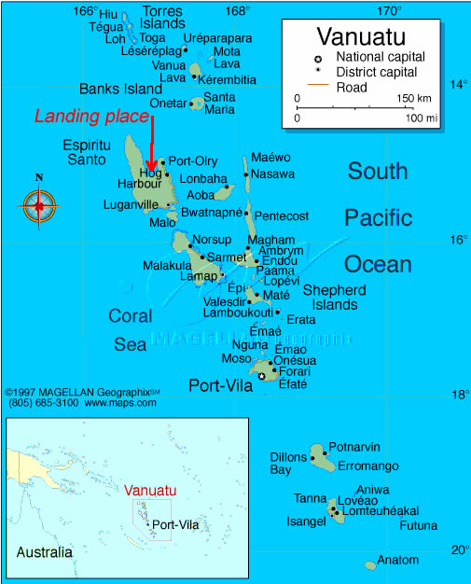

**This maps shows where de Quiros landed.**

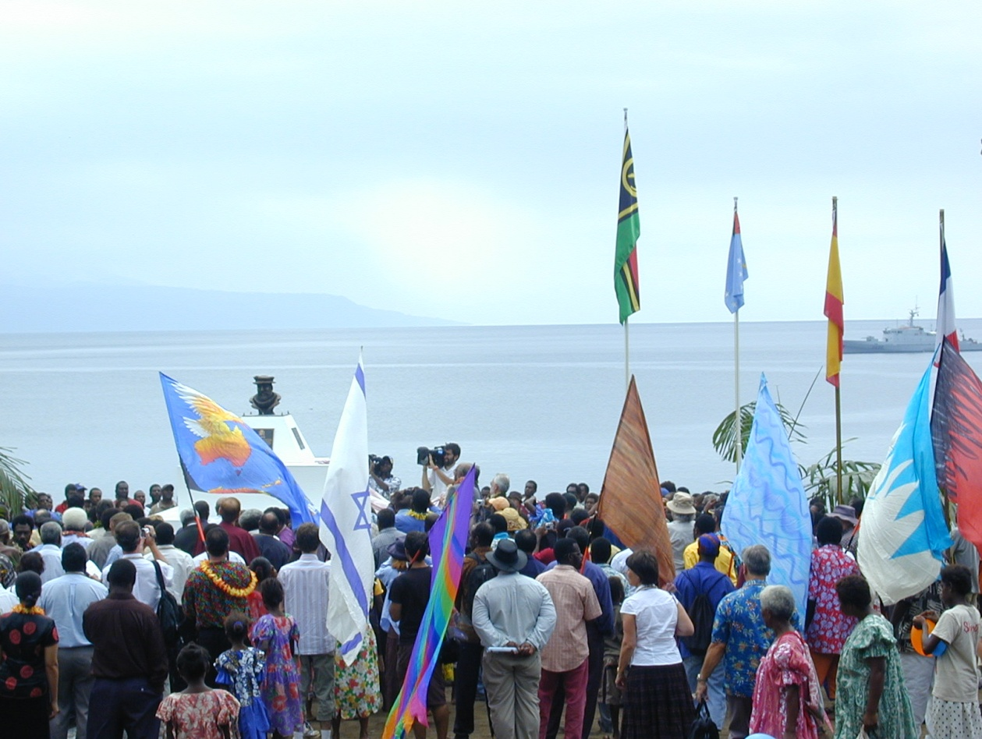

**400 Year Celebrations 2006 at Big Bay Espiritu Santo. See map above.  Note the large landmass in the  background, the reason why de Quiros thought he had discovered a huge continent. A monument of de Quiros has just been unveiled. A French Naval vessel is on the right.**

**For more information follow this link:**

[**http://www.chr.org.au/books/understanding-our-christian-heritage-volume-two/page6.html**](http://www.chr.org.au/books/understanding-our-christian-heritage-volume-two/page6.html)