REMEMBRANCE
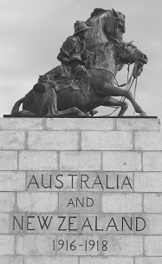
On ANZAC Day, we take time out to remember those who fought for the freedom we now enjoy in this nation, who were prepared to sacrifice their own comforts, safety and lives for those who would come later. They held strongly to their beliefs, and were willing to risk all to maintain them. It is important to remember and give thanks.
It blesses God when we remember all that He has done for us as a nation. He has called us to be His Great Southland, and has positioned His people throughout our history in order to bless us and bring us to Himself.
People of God like Richard Johnson who brought the Word of God to this unknown land with the First Fleet.
Or brave explorers like Charles Sturt, Edward John Eyre, John Forrest and John McDouall Stuart who trekked the vast interior of our rugged land to discover riches that we are still reaping rewards from. They relied on God for strength and direction and acknowledged Him as the source of their success.
Or Christian women like Elizabeth Macarthur, Mary McConnel and Mary MacKillop who overcame great hardships with prayer and reliance on God and made it a better place for those of us who were to follow.
God has used these, and so many more great men and women of God, in mighty ways to bless us in Australia today. He has answered those who have prayed, bringing an end to droughts, granting us a Christian constitution that states that we as a nation are “humbly on the blessing of Almighty God.”
Throughout our history, God’s hand has been evident on Australia. Remembering this gives us a hope for the future. God didn’t do all that for nothing. He knows our potential and He has a good plan for Australia today. Remembering the heroes of our past will help us walk out our destiny in the here and now.

LEST WE FORGET

