THE FIFTY DOLLAR NOTE and the Christian Connection

Another in the series of “and the Christian Connection.”

David Unaipon

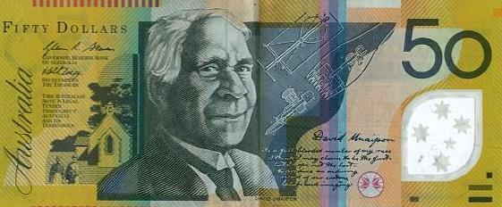

Whirr–whirr–whirr–whirr–whirr… the boomerang sang as it began to circle back through the air towards David’s hand. He caught it with a single deft flick, then fingered the smooth acacia wood, deep in thought. What if…?
There were rumours coming out of America of two brothers who had made a flying machine. One with fixed wings. Surely one with rotating blades, one that whirled like a boomerang, was possible.
Just as Leonardo da Vinci had done four hundred years before him, David Unaipon dreamed of building a helicopter. But, as it was with many of his other scientific ideas, he was unable to find the financial backing to make it a reality.
David’s dad was one–eyed James Unaipon. His mum’s name was Nymbulda. His dad had been brought up in a traditional Aboriginal lifestyle and had undergone an initiation ceremony. He had lost the sight of one of his eyes during a savage tribal fight.
James’ life changed even more dramatically when he was 26 years old. He became a follower of Jesus, was baptised and joined the Scottish Free Church. A missionary taught him how to read and write using the Bible. As the first Christian convert in his tribe, he was keen to share about Jesus with his people and together, he and the missionary went out to visit Aboriginal camps.
At the age of 31, James married Nymbulda. Their wedding was the mission’s first Christian wedding. David was their fourth child. He had eight brothers and sisters.
From an early age, David showed just how smart he was. He started mission school at seven and, just as his dad had done before him, he learned to read and write using the Bible as a textbook.
In 1909 he patented an improved hand tool for sheep shearing. If you look carefully at a fifty dollar note, you’ll see his design. It’s in the middle, on the right of a drawing of his face.
He also invented a centrifugal motor, a multi–radial wheel and a mechanical propulsion device. And in 1914, long before the first helicopter soared into the sky, he got his idea for it from the flight principles of a boomerang.
However, he was unable to secure enough financial backing to fully develop his ideas. Still he gained a reputation of being ‘Australia’s Leonardo’ for his promotion of scientific ideas.
David wrote poetry and authored a number of books. For fifty years he travelled south–eastern Australia, writing, lecturing and preaching in churches and cathedrals. If you look closely again at the fifty dollar note, you’ll see a picture of a church, showing how important Christianity was to him.
He eventually became the Aboriginal spokesperson to the government on many issues connected with the wellbeing of his people.
God blessed David with many gifts and talents. He continued to preach until he was 87 years old. In his sermons he challenged his listeners to consider what God can do for those willing to follow Him. He would say, ‘Look at me and you will see what the Bible can do.’
David always acknowledged God had transformed his life.
In his preface to The Legendary Tales of the Australian Aborigines, which is introduced by Stephen Muecke and Adam Shoemaker, David writes these encouraging words for those of indigenous heritage to come after him: ‘As a full–blooded member of my race I think I may claim to be the first— but I hope, not the last— to produce an enduring record of our customs, beliefs and imaginings.’

David is acknowledged to be the first indigenous Australian writer. His works reside in the State Library of NSW.

His legacy is as an Aboriginal spokesperson and an inventor but, most of all, a man of faith is a testimony to what God can do with a life devoted to him. Are you prepared to allow God to take control of your life?

http://adb.anu.edu.au/biography/unaipon–david–8898
http://adb.anu.edu.au/biography/unaipon–james–13227

Graham McDonald
National Children’s Advocate
Children of the World—a ministry of Campus Crusade for Christ Australia
graham.mcdonald@ccca.org.au

