JUNE DALLY-WATKINS

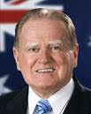
On 2 June 2020, Rev Hon Fred Nile MLC the longest serving NSW parliamentarian(40years), delivered the following tribute to June Dally-Watkins as recorded in the parliamentary Hansard:

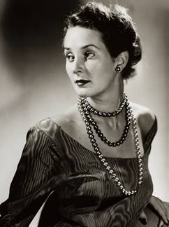
Reverend the Hon. FRED NILE: My adjournment speech is dedicated to my close friend June Dally-Watkins, who died at the age of 92 this year. She had a huge impact on many people's lives. She ought to be remembered in the New South Wales Parliament. June was known throughout Australia as our national etiquette queen, and for good reason. By being one of our greatest promoters of good manners, she drew the public's attention to elegance and style. Members of the public of all ages might agree that these virtues are in decline, which impoverishes us all. June's efforts constituted a singular battle against the decline and she will be remembered for it as her legacy.
June Dally-Watkins was born in 1927. She was educated at Watsons Creek Public School until the age of 15 before moving to Sydney's Willoughby Girls High School. She was named Australia's Model of the Year in 1949 before opening her June Dally-Watkins School of Deportment. "A woman has the right to be beautiful," read the school's first newspaper advertisements. In 1951 her business expanded into the fashion model industry and a number of pageant shows. In 1970 she spearheaded the men's executive course to encourage confidence and class for young men. Because June Dally-Watkins saw etiquette as vanishing in the modern world, in 1988 she established her Business Finishing College to provide training for professionals in business and industry. Her successful career saw her travel throughout Australia, as well as to various countries in Asia and North America, including Hollywood. She established her Business Finishing College in China and had great success there.
I knew June Dally-Watkins to be a woman of faith. After converting to faith in Jesus Christ, in 1953 she married John Clifford, who was as officer of the Royal Australian Navy. She was 27 at the time and the marriage was fruitful, bringing four children into the world: Carel, Timothy, Marc and Lisa. In 1993, she was awarded an OAM for her tireless life of service, but I think it is noteworthy that she refused to retire. June Dally-Watkins's most recent achievements were becoming the ambassador-at-large for the Crossroads International charity, and she almost became a member of the New South Wales Legislative Council for the Christian Democratic Party when I nominated her as part of our upper House team.
She was also helpful and friendly to me. As my wife was busy, she often volunteered to be my partner, especially at regimental army dinners. Her autobiography, The Secrets Behind My Smile, was published in 2002. Nobody can deny that June Dally-Watkins was a powerhouse of energy. She personified all the aspects of our Christian civilisation, of which we should all be proud—manners, decorum and a cultivation that is seen rarely today among public personalities. She reminded us that civilisation requires a constant civilising process to sustain itself. She will be remembered warmly by all those whose lives she touched in the 92 years that she graced us with her presence. If anyone in recent history could be said to be worthy of emulation, June Dally-Watkins was certainly such a person. May her faith in Jesus Christ comfort her as she is now in heaven with our Lord.

