Christian Fellowship Tour Bathurst 19 February 2022
Graham McLennan
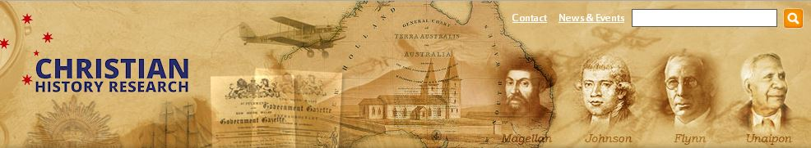 http://www.chr.org.au/
Resources: Books such as Southland of the Holy Spirit,
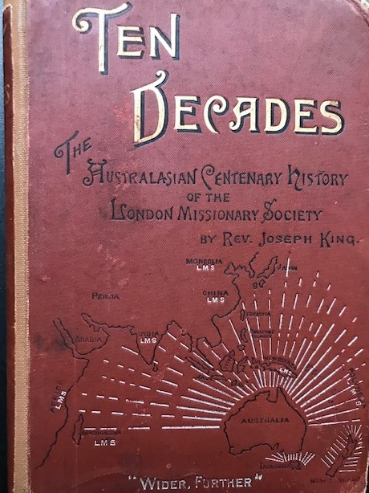 multimedia, biographies, documents, maps, links
Schools.
Revivals: 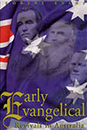 Robert Evans. Hazelbrook. Observatory.

Revival on board a Convict Ship

Click here on a book by Naval Surgeon and Christian, Dr Colin A. Browning MD called The Convict Ship and England's Exiles (London: Hamilton 1847).
Dr Browning did an amazing work amongst the convicts on eight convict voyages between 1831 and 1849. By reading the preface you will understand why 156 of the 220 convicts gave their lives to Christ. By the end of each voyage most could read. The guards had little to do on C. S. Theresa because of the convicts changed behaviour. No floggings, no use of the 220 irons on board…!
ANZAC: 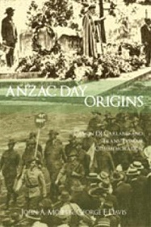 ANZAC DAY ORIGINS. Neil Johnson interviews author John Moses, courtesy of Vision Christian Radio.
Indigenous:
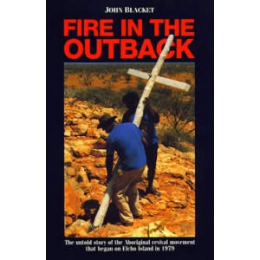
Law/Gov’t
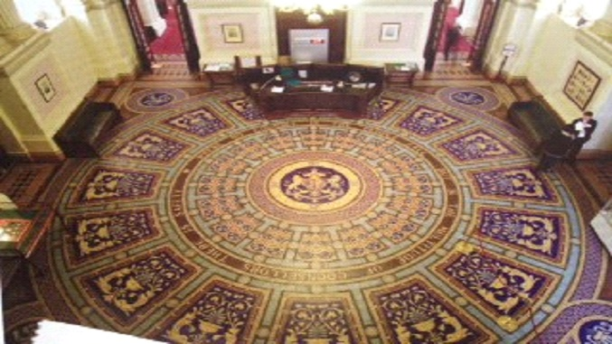
Victorian Parliament
The Vestibule is the main entrance Hall to the Victorian Parliament and was completed in 1879. This parliament was also used from 1901 to 1927 for the Commonwealth Parliament. In the centre of the Vestibule there is a mosaic of the Royal Crest with the words from Proverbs 11:14 "Where no council is the people fall, but in the multitude of counsellors there is safety."
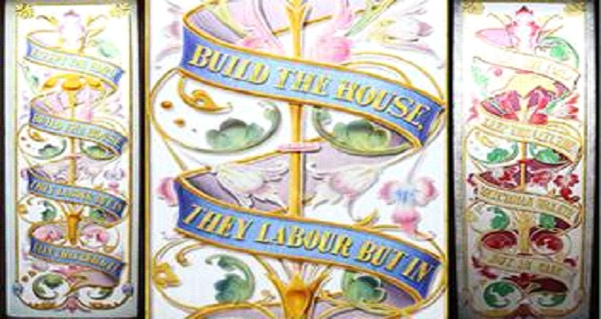
Queensland Parliament House Bible Verse
The two ground floor stained glass windows feature text from The Bible, Psalm 127-1, stating:
Except the Lord build the house, they labour but in vain that build it.
Except the Lord keep the city, the watchman walketh but in vain.

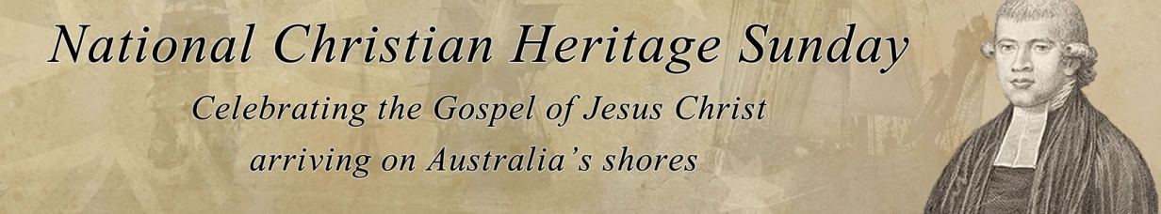
Landing (nchs.net.au)
European Discovery of Australia and its settlement.
When he set out, he didn't know where he was going.
When he got there, he didn't know where he was. When he returned, he didn't know where he had been !i
This has been said about Christopher Columbus though when he set out for the Americas in his four voyages from 1492 to 1502 he recalled:
"...It was the Lord who put into my mind — I could feel His hand upon me — the fact that it would be possible to sail from here to the Indies-All who heard of my project rejected it with laughter, ridiculing me... There is no question that the inspiration was from the Holy Spirit, because he comforted me with rays of marvellous illumination from the Holy Scriptures... For the execution of the journey to the Indies I did not make use of intelligence, mathematics, or maps. It is simply the fulfilment of what Isaiah had prophesied... No one should fear to undertake any task in the name of our Saviour, if it is just and if the intention is purely for His Holy service... the fact that the Gospel must still be preached to so many lands in such a short time — this is what convinces me". ("Book of Prophecies", Christopher Columbus). South America mainly become Catholic because of the Spanish influence.
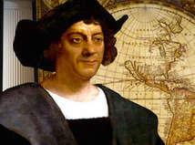
Columbus' voyage ultimately led to the first permanent Protestant English settlement in North America at Jamestown. They placed a cross at Cape Henry now Virginia Beach on April 29, 1607, claiming America for God as his vehicle for spreading the gospel to every nation. With the settlement of the Puritans and Pilgrims the rest has became history.
In Search of the Great South Land
It was Portuguese Catholic, Magellan who opened up the South Seas to the Europeans. Magellan's main purpose was to convert the barbarous nations to Christ. It was his faith that sustained him through terrible deprivations until a strait was found into the Pacific. Magellan's ship was the first to circumnavigate the world from 1519 to 1521, being the first to enter the Pacific via South America ultimately reaching the Philippines which was to become a Catholic nation. This is how they initially became Christians.
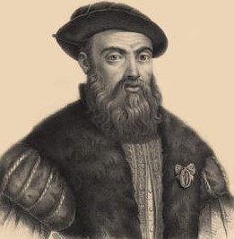
"Magellan having noticed in the Chief's house a sick person in a very wasted condition, asked who he was and from what disease he was suffering. He was told that it was the chief's grandson, and that he had been suffering for two years from a violent fever. Magellan exhorted him to be of good courage, that if he would devote himself to Christ he would immediately recover his former strength. The Indian consented, and adored the cross, and received baptism, and the next day declared that he was well again, rose from his bed and walked about, and took his meals like the others…the Chief and over 2200 Indians were baptized and professed the name and faith of Christ." (George Collingridge, Discovery of Australia‟, p 148)
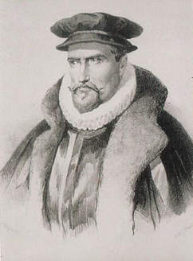 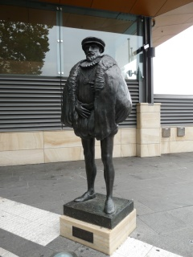 Another sailor Pedro Fernandez de Quiros, a Portuguese Catholic, in 1606 was also seeking to convert the Inhabitants of the south seas to Christianity and believed he finally had discovered "Austr(i)alia Del Espiritu Santo" - a land he dedicated to the Holy Spirit - which he described as being the region of the south as far as the pole. Since he in fact discovered the New Hebrides now known as Vanuatu, the region he described was Australasia, which includes New Zealand.
De Quiros thought he had made it to the shores of Australia but found another country, Vanuatu claiming it for the King of Spain.
It wasn't until Captain James Cook discovered the East Coast of Australia that people realised De Quiros hadn't reached this Southland of the Holy Spirit for there was a separation by sea of several thousand kilometres.
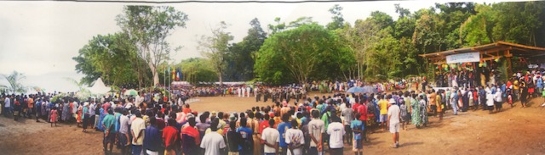
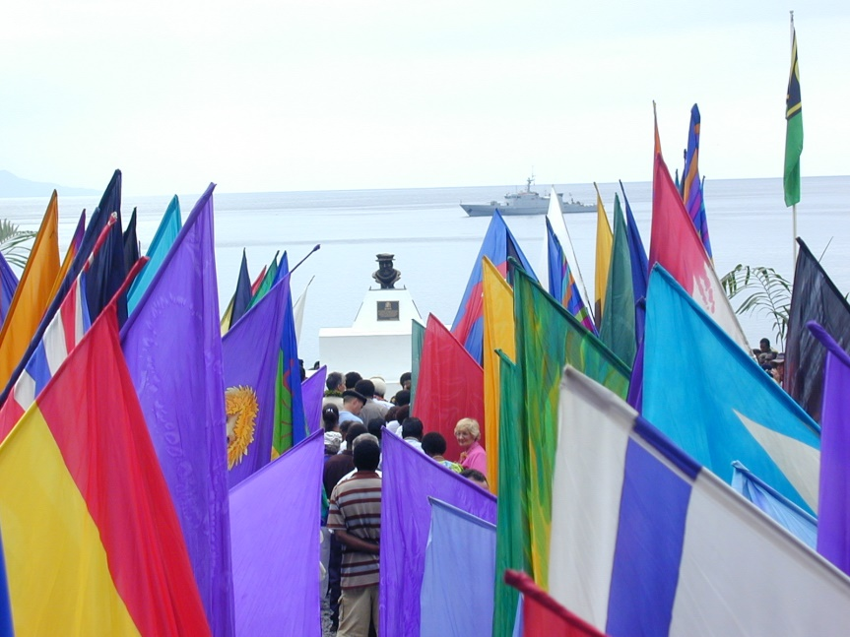
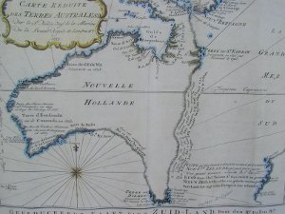
This is one of the very few pre-Cook maps showing only Australia. Produced in 1753 by Frenchman, Jacques Nicolas Bellin, the imaginary line goes from Tasmania to Espiritu Santo to PNG. The coastal note translates: I suppose that the land of Dieman can join with the land of the Holy Ghost but this is without proof."
Joseph Banks the naturalist on board records in his Journal dated 14th May, 1769 about bringing the South Pacific Tahiti natives to a service conducted by Cook.
"It being Sunday, Captain Cook proposed that divine service should be celebrated, but before the time most of our Indian friends had gone home to eat. I was resolved, however, that some should be present that they might see our behaviour, and we might if possible explain to them (in some degree at least) the reasons of it. I went, therefore, over the river, and brought back Tubourai and Tamio, and having seated them in the tent, placed myself between them…”

Of course the west of Australia had been discovered by sailors such as William Dampier, even though a confirmed rogue, Dampier in his preface to "A Voyage to New Holland", an English Voyage of Discovery to the South Seas in 1699, could state:

“I returned to England in the Canterbury East-India-Ship. For which wonderful Deliverance from so many and great Dangers, I think my self bound to return continual Thanks to Almighty God; whose Divine Providence if it shall please to bring me safe again to my Native Country… “
It was William Dampier who left Alexander Selkirk on Juan Ferdandez Island. While in his isolation Selkirk became a Christian. It was this man's story that inspired Daniel Defoe to write "Robinson Crusoe" that in turn inspired Matthew Flinders to become a seafarer, away from the family tradition of Medicine.
Matthew Flinders had the honour of naming Australia and was the first to circumnavigate Australia in 1802-3 with the object "to make so accurate an investigation of the shores of Terra Australis that ...with the blessing of God, nothing of importance would be left for future discoverers upon any part of these extensive coasts".
Sailing from Batavia now known as Jakarta in Indonesia, Dutchman Abel Tasman discovered Tasmania and New Zealand as he set sail in 1642 wrote in his journal; " May God Almighty vouchsafe His blessing on this work." concluding his journey ten months later in 1643 "God be praised and thanked for this happy voyage."
European Settlement
Governor Phillip arrived from England with the First Fleet in 1788 to settle Australia with soldiers and criminals who could no longer be transported to the North America because of American Independence.
His instructions were to "enforce a due observance of religion and good order among the inhabitants, and take such steps for the due celebration of public worship as circumstances would permit. In the first draft of these instructions he was to grant full liberty of conscience, and the free exercise of all modes of religious worship not prohibited by law, provided his charges were content with a quiet and peaceable enjoyment of the same, not giving offence or scandal to government; he was to cause the laws against blasphemy, profaneness, adultery, fornication, polygamy, incest, profanation of the Lord's Day, swearing and drunkenness to be rigorously executed. He was not to admit to the office of justice of the peace any person whose ill-fame or conversation might occasion scandal; he was to take care that the Book of Common Prayer as by law established be read each Sunday and Holy Day, and that the Blessed Sacrament be administered according to the rites of the Church of England. Because of the great disproportion of female to male convicts, he was to take on board at any of the islands any women who might be disposed to come, taking care not to make use of any compulsive measures or fallacious pretences. He was to emancipate from their servitude any of the convicts who should, from their good conduct and a disposition to industry, be deserving of favour, and to grant them land, victual them for twelve months and equip them with tools, grain, and such cattle, sheep and hogs as might be proper, and could be spared. As the military officers and others might be disposed to cultivate the land, he was to afford them every encouragement."
Other nations could have settled Australia but it was their beliefs that prevented them from doing so. The Hindus prevented sea voyages and contact with foreigners, the Chinese In 1433 the voyages of Cheng Ho were ended by another revolution, besides there was a kingdom of women down there! The Muslim sailors before the 1400's believed the southland was Dedjdal or the kingdom of Antichrist! Furthermore European expansion had begun in the East Indies and Pacific ending the expansion of Islam.
Early Christian Influences
The first Christian minister came with the First Fleet. He was recommended by the Society for the Propagation of the Gospel. John Newton and William Wilberforce, two members of the Eclectic Society persuaded England's Prime Minister, William Pitt to accept Richard Johnson's nomination. Johnson an Evangelical churchman, took with him many Bibles, Books of Common Prayer, Psalters and numerous booklets against common sins, and on Sunday 3rd February 1788 he conducted the first Christian Service on Australian soil using as his text Psalm 116:12: "What shall I render unto the Lord for all his benefits toward me."
Writing to his friends in England in a letter about educating the children he wrote:
"It is from a long and ardent wish that the minds of the rising generation of this Colony may be duly thus impressed with such moral and religious sentiment, that the following Plan has been adopted, & Rules & regulations have been made, which I hope every Parent as well as others concerned in bringing up children will see it to be their duty & interest to promote.
Amongst the Rules for the first Christian School in Australia in 1798 are:
1. That this School is to be considered for the Benefit of Children of all Descriptions of Persons, whether Soldiers, Settlers or Convicts, provided they comply with the Rules here laid down.
12. A Form of Prayer to be read by one of the School Masters, & one of Dr. Watt's Hymns to be sung morning & evening. And it is strongly recommended that Parents will send their Children early to School to pray, as they are able, for a Blessing to attend the Instruction given them. (Producing the Currency Lads & Lasses!)
Johnson continued faithfully to proclaim the Gospel until the day he left.
He wrote:

“I trust I have not laboured wholly in vain, and I trust in time, in spite of all opposition and obstacles, God will make bare his holy arm in the conversion and salvation of the souls of men. . . . Last Sunday I preached I suppose to not less than six or eight hundred, and I have since heard that one at least went away sorrowful and heavy-hearted, and some others rejoicing in the Son of God manifested towards them.”

The second clergyman in Australia Samuel Marsden was instrumental in providing lamb as a food source not only here in Australia but as alternative diet for the New Zealand Maori's who like many Pacific islanders were cannibals!
" I can say this that I do not eat the bread of idleness. It is my opinion that God will ere long visit New South Wales with his heavenly grace. Out of these stones he will raise up children unto Abraham. There has not been any shaking yet among the dry bones, but the Son of Man is commanded to prophecy and I hope by and by the Lord will command the wind to blow. Stir up thy strength 0 God & come amongst us." (Ezekiel 37)
He prophetically stated in 1796 "By the Admiral Gambier I have sent to England 4,000 to 5,000 pounds of wool. This will be the beginning of the commerce of this new world. Many think nothing of these things now. They cannot see any advantage to be derived to them, their children, or this settlement by improving the fleeces of our sheep. But I anticipate immense national wealth to spring from this source of commerce in time…I have produced fleeces of very fine wool this year weighing 4 Ib. each…”
Referring to the war with Spain, Marsden reflected: “It is our duty to leave future events to the wisdom of Him who knows all things from the beginning and to act for the present moment.”
My views may be too extended when they anticipate the greatness and wealth of this Country in future, the civilization of the surrounding savage nations and the cultivation of their Islands . Everything must have a beginning, the foundation must be laid before the house can be built. I think you will hear of wheat and other kinds of grain being grown in New Zealand before two years are over. My friend one of the chiefs who has lived with me and acquired a knowledge of agriculture will introduce cultivation among his countrymen. This will add greatly to their civilization and comfort and prepare the way for greater blessings. I may be too fond perhaps of the garden, the field and the fleece. These would be the first object of my attention was I placed among a savage nation. The man who introduced the potato into Ireland and England merited more from those nations than any General who may have slain thousands of their enemies." (Which comes first? Civilising or Christianising, or both?)
Certainly the hand of God is evident in the commencement of a Christian nation in the Pacific within reach of the great Asian nations.
While many Australians look to a convict past with its fear of authority and feeling of inferiority, rejection, isolation and loneliness, there is another history yet to be written, that of our Christian forefathers and their faith and contribution to the kingdom of God - a positive affirmation of a nation with a providential destiny.
It is encouraging to look at some of the godly elements in Australians foundations.
Law and Parliament
Our Common Law has been based on the Christian faith, exemplified by the statue of Jesus occupying the central place above the Royal Courts of Justice in London and by many statements by scholars such as one Chief Justice who declared:
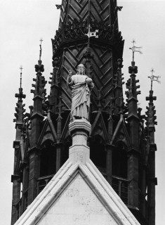
"Christianity is parcel of the Common Law of England and therefore to be protected by it. So whatever strikes at the very root of Christianity tends manifestly to the dissolution of civil government."
Australia's oldest parliament in NSW governed most of Australia and many of the South Pacific islands including New Zealand. It continues to open with this prayer: "Almighty God we humbly beseech thee to vouchsafe thy blessing upon this parliament, direct and prosper our deliberations to the advancement of thy glory and the true welfare of the people, our State and Australia. Amen." A similar prayer is said in our Federal Parliament by the President, on taking the chair each day, shall read the following prayer:
“Almighty God, we humbly beseech Thee to vouchsafe Thy special blessing upon this Parliament, and that Thou wouldst be pleased to direct and prosper the work of Thy servants to the advancement of Thy glory, and to the true welfare of the people of Australia. (Followed by the Lord’s Prayer)
[Our Father, which art in Heaven, Hallowed be Thy name. Thy kingdom come. Thy will be done in earth, as it is in Heaven. Give us this day our daily bread. And forgive us our trespasses, as we forgive them that trespass against us. And lead us not into temptation; but deliver us from evil: For thine is the kingdom, and the power, and the glory, for ever and ever. Amen.”]
Our Australian Constitution was prayed over continually by the man mainly responsible for its passage through the House of Commons, Alfred Deakin.
He became Australia's second Prime Minister, after Edmund Barton who himself was inspired to enter politics by his Presbyterian Minister, Dr Robert Steele. The fourth Prime Minister, Sir George Reid, was also inspired to enter politics through Dr Steele's influence. Deakin, a native born Australian was nurtured in his faith by his mother. It was Deakin who seconded the motion of "Father of Federation." Sir Henry Parkes for the proposed Federation of the Australian States
Deakin kept a Spiritual Diary and from 1884 to 1913 wrote a "Boke of Praer and Praes" containing nearly four hundred prayers, many relating directly to major decisions in his public life, revealing his utter dependence on God. (For a brief time he joined the Theosophy Society but resigned in 1896)
Deakin prayed over the proposed Australian Constitution continually and was delighted when the Constitutional Convention unanimously carried the preamble inclusion "humbly relying on the blessing of Almighty God"
In the concluding words of his book "The Federal Story" Deakin remarks that Federation and the Australian Constitution were 'providential' and were secured only 'by a series of miracles'
In his notes in 1905 Deakin remarks "sufficient to say that the religion of Jesus Christ is the life of the present, the light of the future and the hope of the world." Many years later he stated: "A life, the life of Christ, that is the one thing needful - the only revelation required is there... we have but to live it."
A Christian statesman, he was the first Attorney General of the Commonwealth, and as such, founder of the High Court of Australia. He served three times as Prime Minister when a considerable amount of the Commonwealth's initial legislation was commenced. As Prime Minister he founded the Arbitration Court, the Australian Navy, as well as choosing Canberra as the nation's capital
Polling day for Federation in N.S.W., Victoria and Tasmania was Friday 3rd June 1898. By midnight Deakin knew that Victoria had approved the bill by an overwhelming majority, that Tasmania had done likewise, and that the majority in New South Wales had not reached the minimum number required for the adoption of the Bill. Hence, Deakin prays here "Father of Nations, receive our psalm of thanksgiving. Enable us to pursue the cause of unity in spite of the obstacles which at present appear to beset our path elsewhere. Guide us to appeal to that which is best and purest so as to make its development and mastery sure under our forms of government. Aid us to purify ourselves by our labours for the general weal and to invoke spiritual and moral principles so as to link us with our brethren on the highest plane to which we can at present attain. God preserve this people and grant its leaders unselfish fidelity and courage to face all trials for the sake of brotherhood. Thy blessing has rested upon us here yesterday and we pray that it may be the means of creating and fostering throughout all Australia a Christlike citizenship."

The Constitution Preamble states:
"Whereas the people of New South Wales, Victoria, South Australia, Queensland; and Tasmania humbly relying on the blessing of Almighty God, have agreed to unite in one indissoluble Federal Commonwealth under the Crown of the United Kingdom of Great Britain and Ireland, and under the Constitution hereby established..."
This preamble was in response to numerous signed petitions from people from every colony represented in the Federal Convention. This acknowledgement of the sovereignty of God was approved unanimously and initiated at the Bathurst Constitutional Convention here in Bathurst in
Our Constitutional Christian Monarchy likewise expresses the Lordship of Christ when the Queen is presented with the Bible:
"to keep your Majesty ever mindful of the law and the Gospel of God as the rule for the whole of life and government of Christian Princes, we present you with this Book, the most valuable thing this world affords. Here is wisdom; this is the royal law; these are the lively oracles of God."
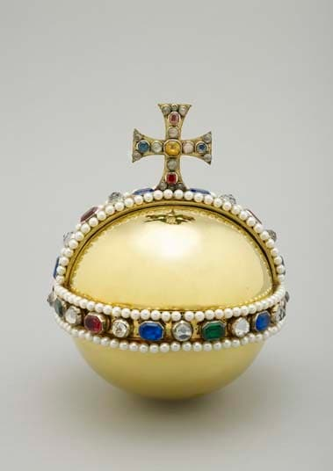 When the Orb is delivered to the Queen the coronation service states:
"Receive this Orb set under the cross, and remember that the whole world is subject to the power and empire of Christ our Redeemer."
Our Australian flag has four Christian crosses. In the Southern Hemisphere God has placed the Southern Cross which is specially incorporated into our national flag, along with the crosses of St Andrew, St Patrick and St George.]]]
The Evangelical Awakening in England also had its effect in Australia and the South Pacific. People such as William Carey were awakened to the need for evangelism of heathen lands through reading "Captain Cooks Voyages"
Many Englishmen became aware for the first time of lands in the Pacific and Asian regions. Commencing In 1784, as part of the Evangelical Awakening, first Baptists, then other nonconformists throughout the Midlands began meeting for one hour on the first Monday in each month to pray for revival which would spread the gospel to the most distant parts of the globe.
This marked the beginning of the greatest period of expansion of the Christian faith since apostolic times. Many missionary organisations were formed, one being the London Missionary Society. By 1826 Carey was responsible for the translation of the Bible into 30 languages in the Pacific and Asian region.
A missionary ship called the "Duff" sailed from England In 1796 to Tahiti with Rowland Hassall and his family. In 1798 the Hassall family arrived in Australia after endangering their lives in Tahiti. Within a short time Rowland Hassall had preached the gospel in all the districts of the colony.
Governor Macquarie and the Evangelical Witness
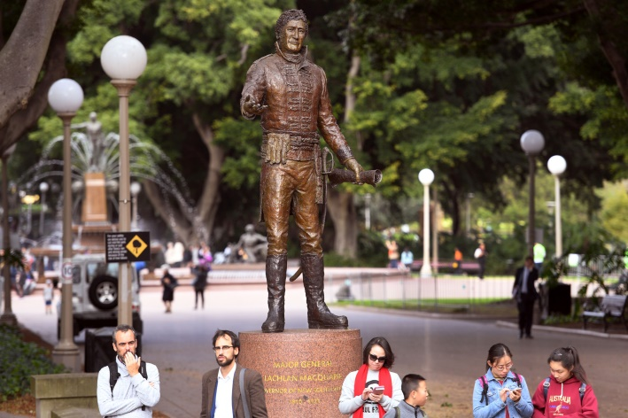
Most of the colonies early leadership came from the evangelical Christian community, many being chaplains. Governors such as Hunter, Macquarie and Brisbane, and a number of officials such as the Judge Advocates, Wylde and Ellis Bent, the editor of Australia's first newspaper were strongly committed to Christian views, as were the school teachers.
Governor Macquarie was always trying to improve the moral and religious well-being of the colony, hoping that those in his care would become good Christians. He personally promoted the British and Foreign Bible Society and the Sunday School Movement. He also encouraged other Christian groups such as the Auxiliary Bible Society, and spoke at the Inaugural meeting.
Macquarie particularly encouraged Christian Education commencing a number of schools under the supervision of the government chaplains so that by 1817 the most common discussion in the pages of the Sydney Gazette was on the merits of Bible reading.
James Stephen, the Permanent Under Secretary of the Colonial Office believed God was going to sovereignly use Australia as a Christian Nation and he was influential in the choice of many Christian leaders to the colony. Amongst them was George Arthur who shared with James Stephen the vision of Australia as a base in South East Asia and the Pacific to reach the Chinese, Hindu and Muslim nations to the North.
South Australia's Godly beginnings and the Aspirations of its Founders
For many years South Australia's capital was known as the Holy City but today it is known as the City of Churches. Adelaide in its formative years couldn't contain all the parishioners in Its churches.
During Adelaide's first eight years there were more preachers and places of worship than in the first decade In New England, U.S.A. From the time of South Australia's settlement in 1836 to 1915 more children attended Sunday School than attended school. In one of the first schools opened by Richard Angas the sole textbook was the bible. Angas had distributed millions of gospel tracts in his lifetime.
Many of South Australia's Founders were Christians. Such people as Robert Torrens who stated in a House of Commons speech In 1827 that "We are co-operating in the scheme of Providence and are the favoured Instrument In causing Christian civilization to cover the earth as the waters cover the sea."(Habakkuk 2:14, Isaiah 11:9)
The person who opened up the southern portion of Australia for free settlement was Captain Charles Sturt, one of Australia's greatest and most heroic inland explorers. He was a man of courage and when faced with major decisions would commit them confidently to God in prayer and thanksgiving.
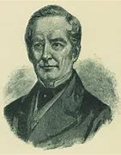
Sturt loved the majesty of the Australian bush and on a number of occasions his life was only spared due to what he acknowledged as divine Intervention. Throughout the pages of his journals Sturt shares his faith constantly, especially when writing to his wife. He used to pray continually for guidance, committing each day’s journey to God.
Charles Sturt loved the majesty of the bush and often praised God for his creation. It was Sturt who in Feb. 1834 wrote to the Colonial Office and believed that the men of South Australia would emulate America in pioneering the inland. He urged them to convince the Aborigine that the white man was coming as a brother. He urged them to protect the Aboriginal against aggression, to care for them as children of God.
Sturt like Marsden was prophetic about the new nation of Australia.
"If indeed, I have been an instrument, in the hands of Providence , in bringing about the speedier establishment of the province of South Australia , I am thankful that I have been permitted to witness the happiness of thousands whose prosperity I have unconsciously promoted. Wherever I may go, to whatever part of the world my destinies may lead me, I shall yet hope one day to return to my adopted home, and make it my resting-place between this world and the next. When I went into the interior I left the province with storm-clouds overhanging it, and sunk in adversity. When I returned the sun of prosperity was shining on it, and every heart was glad. Providence had rewarded a people who had borne their reverses with singular firmness and magnanimity. Their harvest fields were bowed down by the weight of grain; their pastoral pursuits were prosperous; the hills were yielding forth their mineral wealth, and peace and prosperity prevailed over the land. May the inhabitants of South Australia continue to deserve and to receive the protection of that Almighty power, on whose will the existence of nations as well as that of individuals depends!"
Then there were men who believed God had a special purpose in the Christian settlement of Australia. Men such as the Permanent Under Secretary of the Colonial Office, James Stephen, who believed the government should be governed by biblical principles and encouraged Christian families to settle here and Stephens was influential in the choice of Christian leaders in the colonising of the country.
Co-operating with providence
Stephen's desire was to establish Australia as a Christian progressive and wise nation within reach of the Chinese, Hindu and Muslim nations.
Certainly we are seeing the continuing fulfilment of this great prophetic statement given to the Lieutenant-Governor of Van Diemen's land George Arthur, in 1824 as we see countries opening up to the Word of God, and as we see missionaries continuing to be sent out from this nation.
George Fife Angas, who resigned as a Colonisation Commissioner to take up a position of the board of directors of the South Australia Company, was also a committed Christian and the real father of South Australia's religious liberties. 'My great object was, in the first instance, to provide a place of refuge for pious dissenters of Great Britain, who could in their new home discharge their consciences before God in civil and religious duties without any disabilities.' It was the hope of Angas “that South Australia will become the headquarters for the diffusion of Christianity in the Southern Hemisphere.”
It was claimed that in fifty years he circulated over one million copies of scripture, many millions of tracts and two million copies of devotional books such as Spurgeon's 'Morning by Morning' and 'Evening by Evening'. Angas also provided a voluntary non-denominational elementary education for sixpence a week. The schools' sole textbook was the Bible!
Within eight years of Adelaide being established there were more preachers and places of worship than, by comparison, the number in the first decade of New England, USA and within ten years, over half the population of 9,000 were attending two of the denominational churches, Episcopal and Congregational, and further church buildings were necessary. From its settlement in 1836 to 1915 Sunday school enrolments far exceeded those of day schools!
Many Christians settled in this colony, the first in the British Empire not to be officially aligned to the Church of England. A group of German Christians, who had been persecuted in Prussia for refusing to allow a secular sovereign to dictate to them about their faith, settled at Klemzig on the Torrens and at Hahndorf. One of their leaders, Pastor Kavel declared “May South Australia prosper; and all its inhabitants, its immigrants, and all the natives grow together as one blessed nation labouring unanimously for the advancement of those great objectives.”
Next time visiting the Quay please see the South Australian Governor’s Statue Sir George Grey’s along with Sturt and Eyre on the Lands Building and water fountain opposite:
“Jesus answered, “Everyone who drinks this water will be thirsty again, but whoever drinks the water I give them will never thirst. Indeed, the water I give them will become in them a spring of water welling up to eternal life.”
John 4:13,14
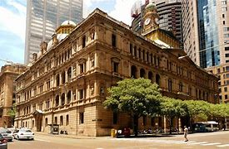
Grey was later to be instrumental in the founding of New Zealand shared with James Stephen the view that 'prayer and meditation on God's Holy Word. . . were the inexhaustible, unfathomable source of all pure consolation and spiritual strength.'
During this time Christians were coming together to discuss the Federation Movement and many were desiring to see God acknowledged as the ruler of the nations and so it was acknowledged in the preamble to our Constitution "...humbly relying on the blessing of Almighty God..."
Even the Sydney Morning Herald's Editorial dated 14th April, 1897 stated "no Christian could in conscience vote for a Federation Bill that did not recognise God"!
Days of Prayer in Australia.
One commenced nearby at Byng with Pastor Tom from the Cornish Settlement in 1838. It was then followed by Governor Gipps on the 2 November and the long devastating drought broke two days later!
The outcome is revealed in an extract from the journal of George Hawke: “As we had made up our mind to keep this day for the purpose of humility and prayer we carried it out…and on that very day…rain fell on us, but it did not extend beyond seven miles in any direction. On that day, a week after the public fast was kept, in which we joined, there was a general breaking of the drought.”
(At Byng there is an historic church built in 1872. It replaced a previous church built in 1842, the first church built west of Bathurst. Before that Parson Tom preached from Bethel Rock.)On the 11th September, 1895 a day of prayer was again called in similar circumstances. Three weeks later a day of thanksgiving was proclaimed to thank God for the breaking of the drought.
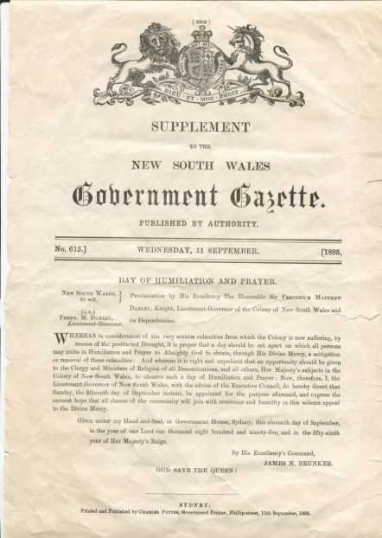
Hebrews 11:32 says 'and what more shall I say? I do not have time to tell about Gideon. Barak, Samson, Jephthah, David, Samuel and the prophets who through faith conquered kingdoms, administered justice, and gained what was promised.
There was of course the Moravian Missionary Latrobe family of Victoria and the remarkable Ludwig Leichhardt who explored much of Australia's north.
Evangelical Christians have been responsible for the creation of some of Australia's foremost inventions. John Ridley, a devout Christian, created the labour saving stripper, and the famous "Sunshine" Harvester was invented by H.V. McKay, who named it in honour of the "Son". It was manufactured in what was to be the largest factory in Australia for many years.
In recent times in Australia we find committed Christians involved in every major area of life such as judges, politicians, scientists, educationists, artists, sports and business people. Christians have also been at the very forefront of community social campaigns and public movements active in preserving Australia's Constitutional heritage and democratic freedoms.
Thus we can see that Australia's discovery, settlement and growth can easily be explained in terms of God's intentions for our nation. He has used His men and women to lead in so many areas of development that even the most humanist historian would have difficulty explaining away the mass of evidence at which this article only hints. If the past is misinterpreted then so is the significance of the future. It is important that we don't continue to be deceived by the secularization process which denies the sovereignty of God in history, and be like Esau who sold his birth right for a meal when Psalm 61:56 says: "You have given me the heritage of those who fear your name."
Christians of Australia can rejoice in the contribution of our Christian forebears and confidently step out in faith aware of God's great intentions for our island continent.

