AUSTRALIA'S JUBILEE AND DAYS OF PRAYER
by Graham McLennan, National Gathering Executive Member & Treasurer
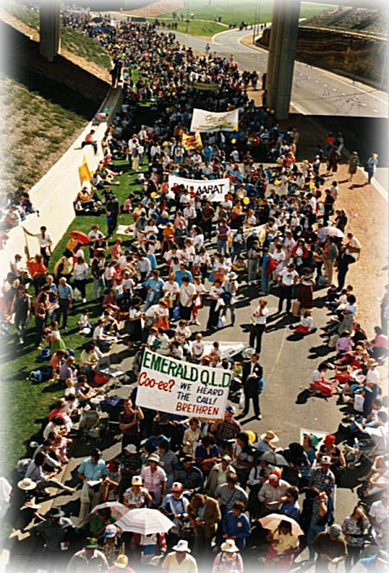

Christians surround New Parliament House with Prayer on the 7th May 1988. State Circle, ten abreast, for 3.5 kms! This photograph enlarged and framed was presented to Federal Members and Senators during the First National Prayer Breakfast in the Great Hall, October 1988, by Dr. Graham McLennan on behalf of the Executive of the National Gathering with the reminder that God will "Bless this House" which became the theme of the Prayer Breakfast.

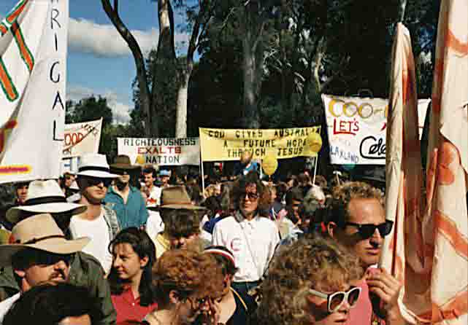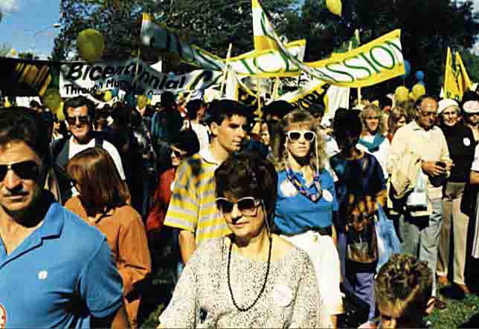

AUSTRALIA'S JUBILEE AND DAYS OF PRAYER
On the 11th June 1738, John Wesley blew the first trumpet call of the great evangelical revival which was to have a deep and lasting effect on Britain and on those in succeeding generations.
Fifty years later a Christian minister gave the first service on Australian soil. The Rev. Richard Johnson was recommended as Chaplain to the first fleet, because of his religious fervour, by men such as William Wilberforce and John Newton. At this service Johnson spoke from Psalm 116, Verse 12 "What shall I render unto the Lord for all his benefits towards me".
Almost 200 years earlier Pedro Fernandez de Quiros had named the region of Vanuatu, and lands south to the Pole which would have included Australia "Australia del Espirito Santo" - the Great South Land of the Holy Spirit and earnt the Holy Jubilee which the Pope had conceded to the expedition.
Fifty years after the arrival of the first fleet, the Governor of N.S.W., George Gipps, a Christian, proclaimed Sunday, November 2, 1838 a national day of fasting and humiliation because of the severe drought. Within two days heavy rains began to fall causing many to come down with the flu! (At one stage N.S.W. governed most of Australia and many of the South Pacific islands including New Zealand.)
In the intervening years on Saturday 13th February 1869 a Day of Humiliation for the drought was appointed by the Government as a day of general humiliation and prayer to the Almighty, on account of the fearful drought that has afflicted for so long a very large portion of the colony(http://trove.nla.gov.au/ndp/del/page/5694916)
In the Cassilis Public School Inspector's report of 1877 it tells of the school closing for a day in November 1877 to allow the children to attend a special church service for "Day of Humiliation and Prayer for Rain" and in February 1878, the children were given a holiday on a day of "Thanksgiving for the breaking of the drought". School Inspector's report 1877
Fifty-seven years later on the 11th September, 1895 a day of prayer was again called in similar circumstances. Three weeks later a day of thanksgiving was proclaimed to thank God for the breaking of the drought.
This was short lived as the years leading up to Federation (January 1901) saw intermittent dry spells over most of the country particularly in 1897 and 1899; in most of Queensland, dry conditions were virtually unbroken from 1897. Most other parts of the country had reasonable rain in 1900 and early 1901, however with the coming of spring 1901 very dry weather set in across eastern Australia. By February 1902 concerns were expressed about Sydney's water supply, and the New South Wales Government declared 26 February a day of 'humiliation and prayer" for rain in that State.
Similar declarations were made in Queensland in April and Victoria in September, as the drought worsened.

The nation not only prayed for drought-breaking rain but were led by the leaders of the Federal and State Governments as can be seen from this short Daily Telegraph report in 1902
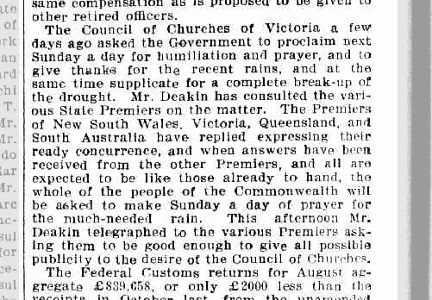

During this time Christians were coming together to discuss the Federation Movement and many were desiring to see God acknowledged as the ruler of the nations and so it was acknowledged in the preamble to our Constitution "...humbly relying on the blessing of Almighty God..."
(Even the Sydney Morning Herald's Editorial dated 14th April, 1897 stated "no Christian could in conscience vote for a Federation Bill that did not recognise God"!)
Churches also campaigned: "that there also be embodied in the said Constitution, or in the Standing Orders of the Federal Parliament, a provision that each daily session of the Upper and Lower Houses of the Federal Parliament be opened with a prayer by the President and Speaker or by a Chaplain". They also asked for the Governor-General to be empowered to proclaim National Days of Thanksgiving & Repentance.
Over a hundred years later in 2004, the Governor-General of the Commonwealth of Australia, His Excellency Major General Michael Jeffery, has fulfilled the desire of many Christians in Australia in the 1890's, and indeed this new millennium, and launched a National Day of Thanksgiving. Now an annual National Day of Prayer and Fasting (Humiliation) has begun in 2010 on the 31 October.
The first Sunday in the 20th Century was proclaimed Commonwealth Sunday and Christians were called to pray for the Nation.
On the 3rd September 1938 Joseph Lyon's called the nation to pray, prior to the outset of World War 11. The PM called for a Day of Prayer for Divine Intervention and Guidance to avoid another World War hoping the Munich Conference would settle many difficulties, pronouncing a National Day of Thanksgiving on Sunday October 9 1938. The Prime Minister Joseph Lyons with wife Enid, first woman in the House of Representatives.
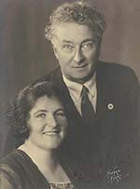

During the 1940's as the second World War began to take its horrific toll and Australia was being threatened, particularly after the bombing of Darwin, several days of prayer were held. One of these was called by King George VI throughout the Commonwealth.

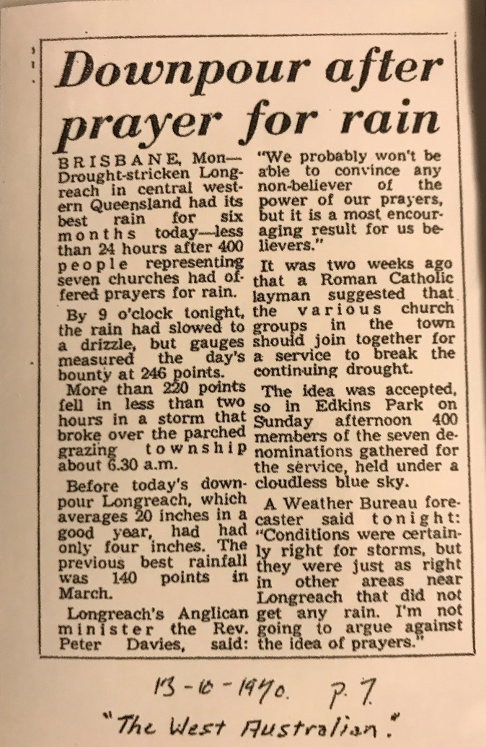

The National Gathering held in 1988
There were numerous National Gatherings in the Old Testament which had ramifications for many years.
For instance in 2 Chronicles 34 the nation followed God for a generation. In Nehemiah 8 when they gathered in the capital their repentance led to national reform and restitution of godly traditions.
Whether it was in ancient Judah or Israel or in gentile Nineveh, when the nation gathered, repented and worshipped God, great blessings always followed.
So we can see that a gathering of a nation's people before God has deep roots and proven blessings in Biblical history.
For example, at the dedication of the first temple under Solomon, the whole nation gathered in Jerusalem and offered sacrifices with singers leading great worship to the Lord (I Samuel 7:4-10).
The result was God's glory coming down on the temple.
We know that God will heal our land if His people humble themselves, seek his face and turn from their wicked ways (2nd Chronicles 7:14).
In the time of Asa, the nation assembled in the capital, offered sacrifices, covenanted to seek and follow God and worshipped joyfully, with the result that God gave them rest on every side (2nd Chronicles 15:8-15).
In the days of Jehoshaphat, they gathered, fasted, prayed, the prophetic word came, they fell down and worshipped, stood up and praised the Lord, so that they saw victory in battle and rest on all sides (2nd Chronicles 20:1-19).
When Hezekiah was king, he called the people to the capital, though some of them mocked, some came. They prayed, offered sacrifices, rejoiced and worshipped to see God answer their prayer and national reforms (2nd Chronicles 30:1-27).
During the reign of Josiah, the nation gathered and God's word was read out and the people covenanted to follow God so that the nation followed God for a generation (1st Chronicles 34).
In the book of Ezra we read (Ezra 10:1-17) that the nation gathered in the rain and the leaders prayed and wept and prostrated themselves before God due to the nation's unfaithfulness with the result that behaviour changed throughout the land.
Again, in the days of Nehemiah, the nation gathered in the capital and fasted in sackcloth and ashes, confessed their sins and their fathers' sins and had God's word read aloud for three hours, then confessed and worshipped God for three hours. The result was that the nation covenanted to follow the Lord.
But this national humbling followed by the great blessing of God was not confined to just ancient Israel and Judah!
We know from the book of Jonah that the gentile city of Ninevah was saved from the severity of national judgement when the Ninevites responded to Jonah's call, fasting in sackcloth and ashes, believing in the true God and calling earnestly on him and turning from their old ways.
The National Solemn Assembly held in Canberra in March 2007 has also awakened Christians.
See this report on the National Solemn Assembly 2007.
SUPPLEMENT TO THE NEW SOUTH WALES GOVERNMENT GAZETTE
No. 612] WEDNESDAY, 11 SEPTEMBER. [1895.
PUBLISHED BY AUTHORITY
DAY OF HUMILIATION AND PRAYER
NEW SOUTH WALES, ) Proclamation by His Excellency The Honorable
to wit. ) Sir FREDERICK MATTHEW
(L.S.) DARLEY, Knight, Lieutenant-Governor of the
FREDK. M. DARLEY, Colony of New South Wales and its Lieutenant-Governor. Dependencies.

WHEREAS in consideration of the very serious calamaties from which the Colony is now suffering, by reason of the protracted Drought, it is proper that a day should be set apart on which all persons may unite in Humiliation and Prayer to Almighty God to obtain, through His Divine Mercy, a mitigation or removal of these calamities: And whereas it is right and expedient that an opportunity should be given to the Clergy and Ministers of Religion of all Denominations, and all others, Her Majesty's subjects in the Colony of New South Wales, to observe such a day of Humiliation and Prayer: Now, therefore, I, the Lieutenant-Governor of New South Wales, with the advice of the Executive Council, do hereby direct that Sunday, the fifteenth day of September instant, be appointed for the purpose of aforesaid, and express the earnest hope that all classes of the community will join with reverence and humility in this solemn appeal to the Divine Mercy.
Given under my Hand and Seal, at Government House, Sydney, this eleventh day of September, in the year of our Lord one thousand eight hundred and ninety-five, and in the fifty-ninth year of Her Majesty's Reign.
By His Excellency's Command,
JAMES N. BRUNKER
(see next page)

GOD SAVE THE QUEEN!

SYDNEY:
Printed and Published by Charles Potter, Government Printer, Phillip-street, 11th September, 1895.

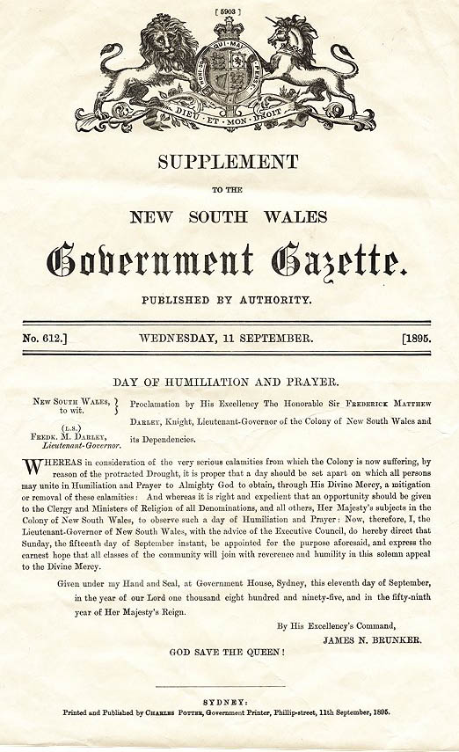

NEW SOUTH WALES
GOVERNMENT GAZETTE
Extraordinary.
Published by Authority.
No. 662] Wednesday, 2 October, [1895.

New South Wales, to wit (l.s.) Fredk. M. Darley Lieutenant-Governor.
Proclamation by His Excellency The Honorable Sir Frederick Matthew Darley, Knight, Lieutenant-General of the Colony of New South Wales and its dependencies.
Whereas it is deemed fitting that the inhabitants of New South Wales should testify their thank-fulness to Almighty God for his great mercy in sending the welcome rain with which the Colony has recently been blest: Now, therefore, I, Sir Frederick Matthew Darley, as such Lieutenant-Governor as aforesaid, do, with the advice of the Executive Council, hereby appoint Sunday, the sixth day of October instant, to be observed as a Special Day of Prayer and Public Thanksgiving throughout New South Wales; and I further invite the Clergy and Ministers of Religion of all Denominations, and all other Her Majesty's subjects in the Colony of New South Wales, to observe the day appointed as one of special Thanksgiving to Almighty God for His great Mercy in delivering the Colony from the suffering and loss attending a long continued drought.
Given under my Hand and Seal, at Government House, Sydney, this second day of October, in the year of our Lord one thousand eight hundred and ninety-five, and in the fifty-ninth year of Her Majesty's Reign.
By His Excellency's Command,
JAMES N. BRUNKER

(see next page)

GOD SAVE THE QUEEN!

Sydney
Printed and published by Charles Potter, Government printer, Phillip-street, 2nd October, 1895.

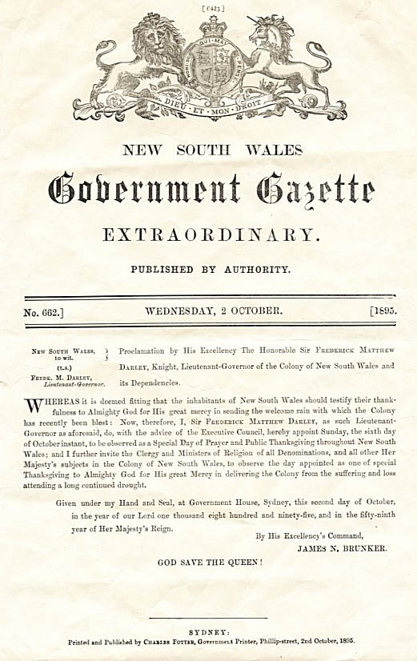

JOURNEY TO THE NATIONAL GATHERING
In 1986 the National Alliance for Christian Leadership was established, comprising a diverse range of theological persuasions. At one point during its first assembly, delegates broke into small groups for intercession. The Lord soon made clear that a large national Christian witness was to take place in 1988. At the conclusion of the assembly, a prayer chain was established by Youth With A Mission, Intercessors for Australia and others to pray continually until the end of the bi-centenary year.
Shortly afterwards Des Higgs, from the Ministry of 10,000 Men, took up the challenge to gather people from across the nation and to join with Fusion. The Fusion group had prayed around Parliament previously and had determined that May 7 and 8, immediately prior to the opening of the New Parliament House, was the most appropriate time to stage a huge Christian witness, to proclaim Christ in the capital and to pray for our government and nation.
The evening before the "Big Day", we gathered to share and exchange final instructions. It was pouring buckets of rain, but none of us on the Executive ever doubted that we were to have pleasant weather. We remained confident in God, whatever the outcome. At the same time, we were well aware that we needed to raise $45,000 next day to meet our financial commitments and knew that the offering would be a disaster if there was consistent rain.
That night we listened to many of the workers sharing about God's provision regarding items required for the event, and all felt a little humbled as a result. Rain was still pouring down as we closed the meeting and prepared for out last sleep for some considerable time. We woke next morning to a gloriously sunny autumn day, with not a cloud in the sky!
After the March round the New Parliament House, people assembled on the "Federal Mall", as it had just been named. It was intensely moving to view the 35 to 40,000 people from our "Treasury Office" - the O'Connor Uniting Church double-decker bus!
The Lord had been bringing the verse - "He will abundantly provide above what you are able to ask or think" - to my mind a number of times, even from the very outset of the Executive meetings. God's people were very generous over the week-end. Over $30,000 was in the offering on the Saturday afternoon, $18,000 in the evening and $5,300 during the Sunday morning sunrise service, apart from $12,000 profit from the sale of badges entitled "We Opened New Parliament House with Prayer". This meant that we could go ahead with plans for a video and a paperback to record the event!
Toilet facilities had to be provided for the expected crowds at the Opening on Monday, May 10th. By the Grace of God, the authorities decided to have them functioning two days earlier, a huge saving for us.
Over $80,000 was donated in free printing, stickers, letterheads, ribbons and so on, and 32,000 apples (from Orange!) were provided at less than 3 cents each.
Canberra Christians opened their homes, acting as hosts to thousands of interstate people. Y.W.A.M. and Fusion personnel provided thousands of voluntary man-hours in labour. Groups such as Calvary Chapel, Christian Community School, Kings Kids, the International Institute of Creative Ministries, put many hours into rehearsals.
It was interesting to see how the theme changed throughout the week-end: starting with the March upon Parliament House - to prayer, reconciliation, celebration and worship - as the evening prayer vigils of concern for the nation - to intercessory prayer leading to repentance - and finally, at the N.A.C.L. Assembly on the Monday, to humility, "If My people who are called by Name will humble themselves..."
A little weary and dishevelled, I stood on the platform at dawn on Sunday, watching the sun rise in the North-East, aware that, in a very real sense, God was birthing a New Day in this nation of Australia.
Double the number attended the National Gathering as attended the official opening of New Parliament House. A service for employees working on the building was conducted by a chaplain later in the week and a Christian service of Parliament in the Great Hall to mark the beginning of the first session of Parliament in the New Parliament House was attended by over 2,000 people.
National Gathering Pictures
Credit: Graham McLennan unless otherwise indicated.

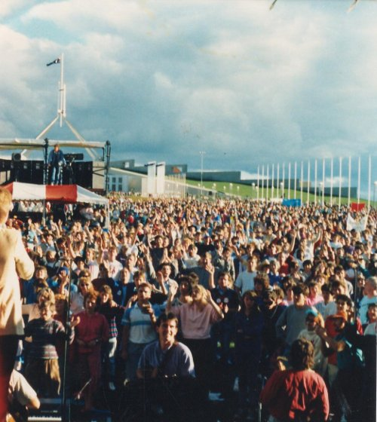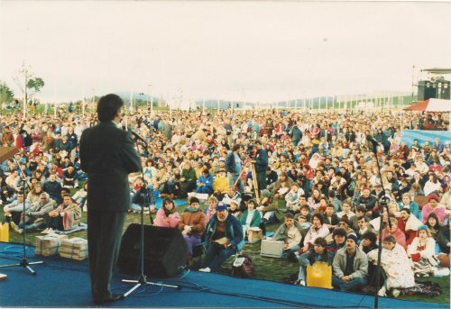
Looking toward New Parliament House from the National Gathering Stage.
In worship, praise and thanksgiving to God for all His benefits toward us, taking seriously the question raise in the first Christian sermon ever preached on Australian shores from Psalm 116 "What shall we render to the Lord for all His benefits toward us?"

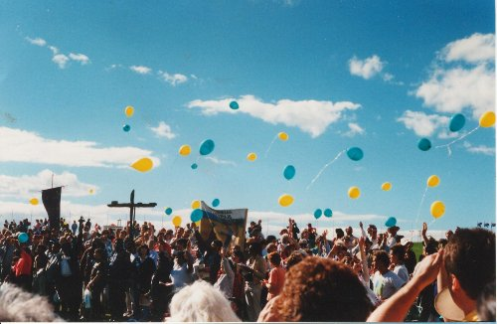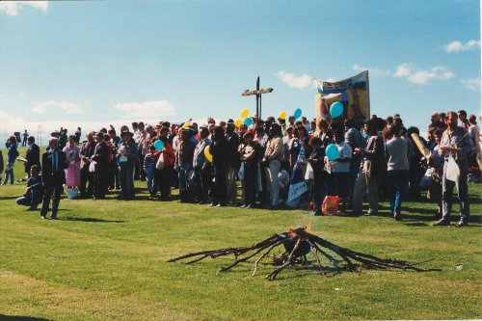
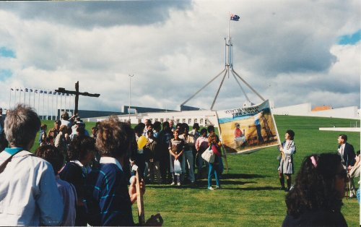
Reconciliation celebrated with the Aboriginal Christian community. The cross made from the sliprails of Myall Creek stands above the crowd at the National Gathering in 1988.

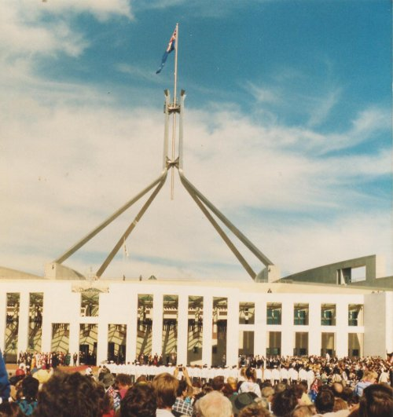
New Parliament House finally opened with prayer. "Jesus is the Light of the world", declares Rt. Rev. Owen Darling, Bishop of Canberra-Goulburn.
At the base of the flag support, second from right, is the highest room in the building, set aside for prayer, known as the "upper room".

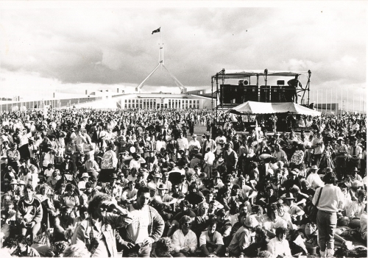
The National Gathering, Credit: Worldwide Photos

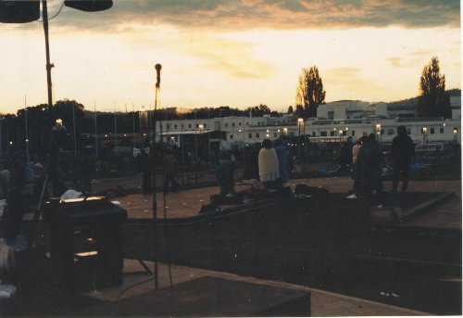

A New Day Dawns
Looking towards Old Parliament House from the Western Prayer Podium, at the conclusion of ten hours of continual prayer through the night for the Nation.

