Public Christian Symbols in Australia
We are compiling a list of similar icons for the www.chr.org.au website and for the Inaugural National Christian Heritage Sunday 3rd February 2013. Do you know of others?
Please contact nacl@netwit.net.au
Sydney Fountains
Amongst the many public Christian symbols in Australia are these remarkable drinking fountains in Sydney with the inscription from John 4:13-14
"Whosoever drinketh of this water shall thirst again; But whosoever drinketh of the water that I shall give him shall never thirst."
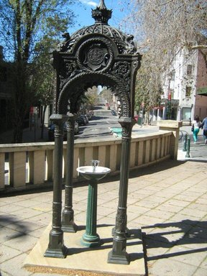
Above. Fountain cnr of Oxford and Riley Streets Sydney
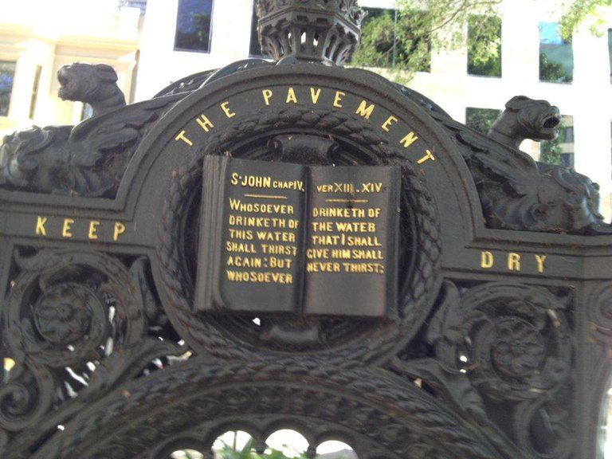
Above. Scripture highlighted on fountain in Macquarie Place cnr Bridge and Loftus Streets near Circular Quay
Read more of the Sydney fountains.

Federation Pavilion, Centennial Park, Sydney
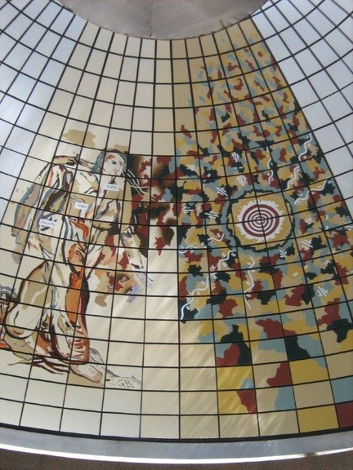
Pavilion erected in 1988 which contains the 1901 monument of the Federation of the six states.
The picture of the man contains the words: Faith, Hope & Charity - near tie, right chest & hip.

Richard Johnson Square, Bligh and Hunter Sts, Sydney
Memorial to the Bicentenary of Christian Education 1793-1993
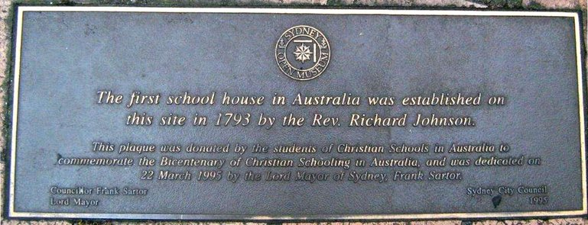
Two Memorials Dedicated to the Memory of John Flynn
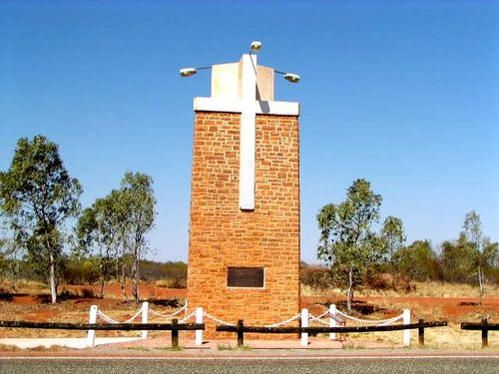
Stuart Highway Memorial NT
Commemorating Flynn of the Inland. The very Reverend John Flynn OBE. DD of the Presbyterian Church of Australia 1880-1951 His vision encompassed the continent. He established the Australian Inland Mission and founded the Flying Doctor Service. He brought lonely places a spiritual ministry and spread a mantle of safety over them by medicine, aviation and radio.
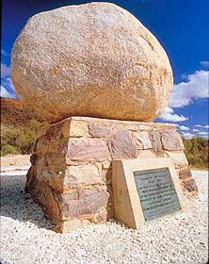
John Flynn's Grave, near Alice Springs NT
The John Flynn's Memorial Historical Reserve, located seven kms west of Alice Springs, is the resting place for the ashes of the Reverend John Flynn, founder of the Flying Doctor Service and the Australian Inland Mission.
The grave is on a low hill at the foot of the MacDonnell Ranges. The plaque expresses a lifetime achievement in just a few lines:
'His vision encompassed the continent. He established the Australian Inland Mission and founded the Royal Flying Doctor Service. He brought to lonely places a spiritual ministry and spread a mantle of safety over them by medicine and the radio.'

Victorian Parliament
The Vestibule is the main entrance Hall to the Victorian Parliament and was completed in 1879. This parliament was also used from 1901 to 1927 for the Commonwealth Parliament. In the centre of the Vestibule there is a mosaic of the Royal Crest with the words from the Book of Proverbs 11:14:
"Where no council is the people fall, but in the multitude of counsellors there is safety."
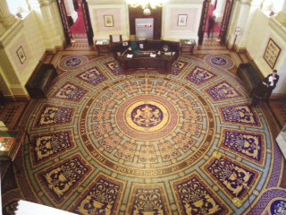

Ebenezer Church
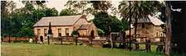
Ebenezer Church Is Australia's oldest church, est. 1809 at Ebenezer, NSW and the oldest extant school building in Australia.
Read more at http://www.ebenezerchurch.org.au/index.htm
Sheffield Murals - Christian Heritage
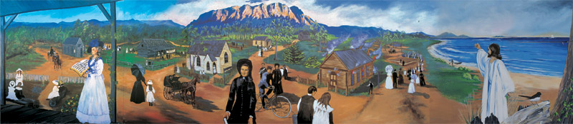
The historical roots of each Christian denomination in Kentish along with approximately 140 people are depicted in this mural. The mural shows the arrival of the first Methodist clergyman in 1860, the Christian Brethren evangelists meeting in farmers’ barns and the building of the Anglican and Salvation Army Churches.
We also see the huge crowds that came to respond to Joseph Lyons (later to become Prime Minister) as he appealed for funds to build the Catholic Church and the spectacular fire which gutted the Baptist Tabernacle in 1930. The mural includes an impression of the many who have left for overseas in mission fields.
Painted in 1988 by: Cheyne Purdue
Location: Pioneer Crescent, Sheffield, Tasmania
Size: 12m x 2.4m
© Sheffield Inc.

