**Our Australian Christian Constitutional Monarchy**

Queen Elizabeth’s image on the $5 note as well as on our six coins representing our Australian Christian Constitutional Monarchy.

[Image result
          for australian currency 5 dollar notes](http://www.google.com.au/imgres?imgurl=http://i.telegraph.co.uk/multimedia/archive/01666/australianote_1666615i.jpg&imgrefurl=http://www.telegraph.co.uk/finance/personalfinance/9064314/Can-Bristols-banknotes-match-the-worlds-most-beautiful-currencies.html?image=2&h=400&w=620&tbnid=HXtoS0am6XXb4M:&zoom=1&docid=8Kdm13CFQfqmDM&ei=JEUdVaDxG5PX8gXD0YGIBQ&tbm=isch&ved=0CB0QMygBMAE)

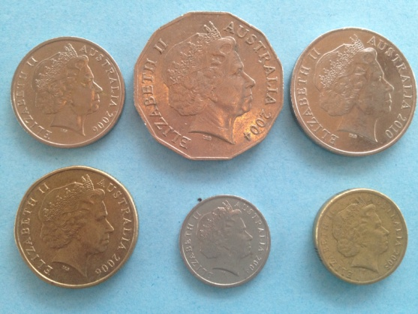

**During the Coronation Service which is reproduced here on the** [**Christian Heritage Website**](http://www.chr.org.au/books/understanding-our-christian-heritage-volume-one/page7.php)**, not only does The Queen take Communion, the Gospel is pronounced, the Apostles Creed read, the Queen is also presented with the Bible with the words:**

“**Our gracious Queen:  
to keep your Majesty ever mindful of the law and the Gospel of God as the Rule for the whole life and government of Christian Princes, we present you with this Book, the most valuable thing that this world affords.**

**Here is Wisdom;  
This is the royal Law;  
These are the lively Oracles of God.**

**She is also presented with the Orb with the words:**

**“Receive this Orb set under the Cross,  
and remember that the whole world  
is subject to the Power and Empire  
of Christ our Redeemer.”**

**After the crown is placed on the Queen's head the Archbishop says:**

**God crown you with a crown of glory and righteousness,  
that having a right faith and manifold fruit of good works,  
you may obtain the crown of an everlasting kingdom  
by the gift of him whose kingdom endureth forever. Amen.**

***Then shall the choir sing:***

**Be strong and of a good courage:  
keep the commandments of the Lord thy God, and walk in his ways.**

**Followed by the Benediction**

**The Lord bless you and keep you.  
The Lord protect you in all your ways  
and prosper all your handy work. Amen.**

**The Lord give you faithful Parliaments and quiet Realms;  
sure defence against all enemies;  
fruitful lands and a prosperous industry;  
wise counsellors and upright magistrates;  
leaders of integrity in learning and labour;  
a devout, learned and useful clergy;  
honest peaceable and dutiful citizens. Amen.**

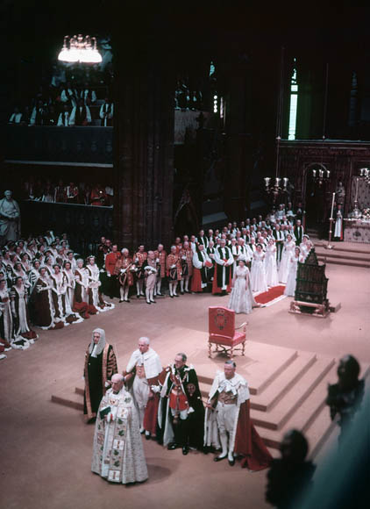

Queen Elizabeth progresses past the Coronation Chair