THE TWENTY DOLLAR NOTE and the Christian Connection

Another in the series of “and the Christian Connection.”

The Reverend John Flynn

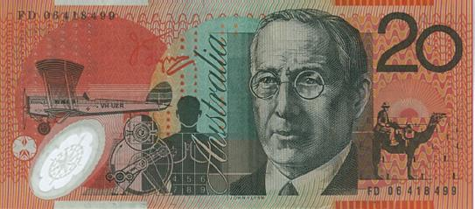

Thomas and Rosetta Flynn were godly parents. John, his older brother and sister, were raised in a home where Jesus was acknowledged as Lord. John was only two years of age when tragedy struck, his mother passed away and difficult times followed. John found himself more often than not being raised by relatives.

In his teens he made a decision to become a follower of Jesus but little did John know what great plans God had for his life because of that decision.

In 1901 the year of Federation he wrote;
“Dear Dad, I’ll be 21 in a fortnight and have been thinking that I should give you my thoughts concerning the future - the more I think and the more I see the grandeur and beauty of Christianity and the hollowness of human life considered as complete in itself . . .”, and he mulled over that proposition and then continued, “if Jesus of Nazareth is indeed the Son of Almighty God; if He was in reality ‘God with us’ showing us the Father; if it is a fact that we only sojourn on this earth for a while, and then appear before the Creator of the universe. . . what more honourable calling can a man follow than getting his fellows to realise this fact and act upon it?”

Such were his beginnings and achievements, that in recognition of his founding of the largest and most comprehensive aero-medical health care service in the world 'The Royal Flying Doctor Service” it is his face that looks out from the Australian Twenty Dollar note.

His calling was to minister to those white settlers and the indigenous Aborigines living in the remote parts of outback Australia.

The first “medical home” was established at Oodnadatta, in 1912 due to a very generous gift from a friend. This was opened by Rev Robert Mitchell with the words, “In the Name of Jesus of Nazareth the Great Healer and Redeemer of men, I trust that every person entering this medical home will go out cured of infirmity and blessed in soul as well as body.”

Then down came the rain, a rare occurrence on this opening day. A blessing. A seal. The rain water tanks were full. Many Christian nurses heeded the call and joined, as it was then known, the Australian Inland Mission.

Flynn's work with the flying doctor and the pedal radio were to transform him from being simply a church leader to a figure of national and eventually international significance.

By the 1950's, the Royal Flying Doctor Service was acknowledged by former Prime Minister Sir Robert Menzies as "perhaps the single greatest contribution to the effective settlement of the far distant country we have witnessed in our time."

John Flynn’s undoubted motivation was to show the love of Jesus to everyone he met.

Maybe God is calling you to do something great for Him?

For an excellent inter-active presentation of John Flynn’s life visit www.chr.org.au

Graham McDonald
National Children’s Advocate
Children of the World a ministry of Campus Crusade for Christ Australia
graham.mcdonald@ccca.org.au
www.children.org.au

