Australia's Christian Foundations and Heritage
by Dr Graham McLennan 2014
God’s Grace over Australia
This year as we celebrate our Christian heritage especially on Australia Day which this year falls on a Sunday as well as the National Christian Heritage Sunday (www.nchs.net.org) the following week on the 2nd February.
A new book One People, One Destiny will be available next month written by Mike Spencer who says:
“The purpose of One People, One Destiny is to show God’s dealings, in the context of a comprehensive general history of Australia. The twelve chapters trace Australia’s heritage from Biblical times through the course of significant Christian influences in Australia’s History”.
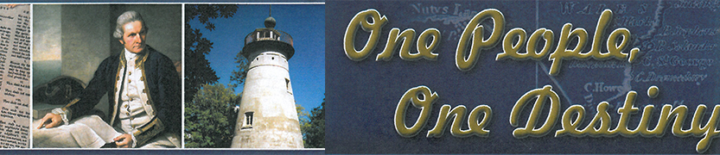
It is interesting that Mike, a New Zealander has written a book on our Australian Christian heritage the very year that New Zealanders will be celebrating on Christmas Day the bicentenary of the bringing of the Gospel of Jesus Christ to their shores from Australia by Samuel Marsden. (http://www.nchs.net.au/nzgospel.htm)
Our Foundations
The story of Aboriginal contact with Christianity is detailed in the book One Blood written by Dr John Harris. 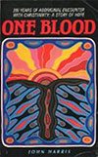 ( Read the book at http://www.chr.org.au/page1.html )
It is both an inspiration and hope but is also a story of sadness and despair, with the aboriginal contact of white man’s human depravity and disease causing tremendous grief to these prior people who had themselves pushed earlier arrivals to Tasmania. With the arrival of the English who pioneered and established a nation we now see aboriginal people embracing the Christian faith more than the rest of us!
However there is hope for us as we see indications of repentance and renewal. A great story recently to emerge is that of the notorious Ned Kelly who repented of his sins before facing the gallows! (Is Ned Kelly in Heaven? Kerry Medway).
It is encouraging as well as instructive to look at some of the godly elements displayed in Australia's colonial history, and its foundations.
Our oldest parliament in NSW opens with this prayer. "Almighty God we humbly beseech thee to vouchsafe thy blessing upon this parliament, direct and prosper our deliberations to the advancement of thy glory and the true welfare of the people, our State and Australia. Amen."
A similar prayer is said in our Federal Parliament. Our Australian Constitution was prayed over continually by the man mainly responsible for its passage through the House of Commons. Alfred Deakin, who was later to become Prime Minister, regarded the Federal Constitution as providential and that it only came into being through a series of miracles. The Constitution Preamble states: "Whereas the people of New South Wales, Victoria, South Australia, Queensland; and Tasmania humbly relying on the blessing of Almighty God, have agreed to unite in one indissoluble Federal Commonwealth under the Crown of the United Kingdom of Great Britain and Ireland, and under the Constitution hereby established...." This preamble was in response to numerous signed petitions from people from every colony represented in the Federal Convention.
Our Constitutional Christian Monarchy likewise expressed the Lordship of Christ when the Queen was presented with the Bible:"to keep your Majesty ever mindful of the law and the Gospel of God as the rule for the whole of life and government of Christian Princes, we present you with this Book, the most valuable thing this world affords. Here is wisdom; this is the royal law; these are the lively oracles of God." When the Orb was delivered to the Queen the Coronation Service stated: "Receive this Orb set under the cross, and remember that the whole world is subject to the power and empire of Christ our Redeemer." 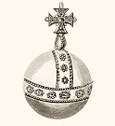
Our Australian flag has four Christian crosses. In the Southern Hemisphere God has placed the Southern Cross which is specially incorporated into our national flag, along with the crosses of St Andrew, St Patrick and St George.
As Christians we need to reflect on our foundations and recognise the hand of God in the commencement of a Christian nation in the Pacific within reach of the great Asian nations. While many Australians look to a convict past with its fear of authority and feeling of inferiority and isolation, there is another history; that of our Christian forefathers and their faith and contribution to the kingdom of God—a positive affirmation of a nation with a providential destiny.
It was Portuguese Catholic, Magellan who opened up the South Seas to the Europeans. Magellan's main purpose was to convert the barbarous nations to Christ. It was his faith that sustained him through terrible deprivations until a strait was found into the Pacific. Pedro Fernandez de Quiros, another Portuguese Catholic, was also seeking to convert the Inhabitants of the south seas to Christianity and believed he finally had discovered "Australia Del Espiritu Santo"—a land he dedicated to the Holy Spirit—which he described as being the region of the south as far as the pole. Since he in fact discovered Vanuatu( the New Hebrides) the region he described includes all of Australasia, which encompasses New Zealand as well.
Abel Tasman was the first European to sight New Zealand and Tasmania and on his return wrote in his journal "God be praised and thanked for this happy voyage." Tasman was encouraged by the voyages of Christopher Columbus who stated: "...It was the Lord who put into my mind—I could feel His hand upon me—the fact that it would be possible to sail from here to the Indies. All who heard of my project rejected it with laughter, ridiculing me.... There is no question that the inspiration was from the Holy Spirit, because He comforted me with rays of marvellous illumination from the Holy Scriptures... For the execution of the journey to the Indies I did not make use of intelligence, mathematics, or maps. It is simply the fulfilment of what Isaiah had prophesied ... No one should fear to undertake any task in the name of our Saviour, if it is just and if the intention is purely for His Holy service... the fact that the Gospel must still be preached to so many lands in such a short time—this is what convinces me." ("Book of Prophecies," Christopher Columbus).
The first Christian minister came with the First Fleet. He was recommended by the Society for the Propagation of the Gospel. John Newton and William Wilberforce, two members of the Eclectic Society persuaded England's Prime Minister, William Pitt to accept Richard Johnson's nomination. 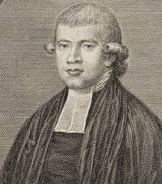
Johnson an evangelical churchman, took with him many Bibles, Books of Common Prayer, Psalters and numerous booklets against common sins, and on Sunday 3rd February 1788 he conducted the first Christian Service on Australian soil using as his text Psalm 116:12: "What shall I render unto the Lord for all his benefits toward me."
The Evangelical Awakening in England also had its effect in Australia and the South Pacific. People such as William Carey were awakened to the need for evangelism of heathen lands through reading "Captain Cooks Voyages." Many Englishmen became aware for the first time of lands in the Pacific and Asian regions. Commencing In 1784, as part of the Evangelical Awakening, first Baptists, then other non conformists throughout the Midlands began meeting for one hour on the first Monday in each month to pray for revival which would spread the gospel to the most distant parts of the globe.
This marked the beginning of the greatest period of expansion of the Christian faith since apostolic times. Many missionary organisations were formed, one being the London Missionary Society. By 1826 Carey was responsible for the translation of the Bible into 30 languages in the Pacific and Asian region. A missionary ship called the "Duff" sailed from England In 1796 to Tahiti with Rowland Hassall and his family. In 1798 the Hassall family arrived in Australia after endangering their lives in Tahiti. Within a short time Rowland Hassall had preached the gospel in all the districts of the colony.
Most of the colonies early leadership came from the evangelical Christian community, many being chaplains. Governors such as Hunter, Macquarie and Brisbane, and a number of officials such as the Judge Advocates, Wylde and Ellis Bent, the editor of Australia's first newspaper, were strongly committed to Christian views, as were the school teachers.
Governor Macquarie was always trying to improve the moral and religious well being of the colony, hoping that those in his care would become good Christians.
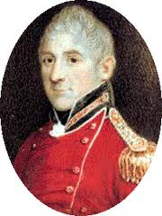 He personally promoted the British and Foreign Bible Society and the Sunday School Movement. He also encouraged other Christian groups such as the Auxiliary Bible Society, and spoke at the Inaugural meeting. Macquarie particularly encouraged Christian Education commencing a number of schools under the supervision of the Government Chaplains, so that by 1817 the most common discussion in the pages of the Sydney Gazette, was on the merits of Bible reading.
James Stephen, the Permanent Under Secretary of the Colonial Office believed God was going to sovereignly use Australia as a Christian Nation and he was influential in the choice of many Christian leaders to the colony. Amongst them was George Arthur, who shared with James Stephen, the vision of Australia as a base in South East Asia and the Pacific to reach the Chinese, Hindu and Muslim nations to the North. Captain Charles Sturt was a great Australian pioneer and heroic inland explorer. Sturt was a man of considerable courage, faith and prayer and was responsible for opening up most of Southern Australia to free settlement. Sturt loved the majesty of the Australian bush and on a number of occasions his life was only spared, due to what he acknowledged as divine intervention. Throughout the pages of his journals Sturt shared his faith constantly, especially when writing to his wife. He used to pray continually for guidance, committing each day's journey to God.
For many years South Australia's capital was known as the Holy City, but today it is known as the City of Churches. Adelaide in its formative years couldn't seat all the parishioners in their churches. During Adelaide's first eight years there were more preachers and places of worship than in the first decade in New England, U.S.A. From the time of South Australia's settlement in 1836 to 1915 more children attended Sunday School than attended school. In one of the first schools opened by George Fife Angas the sole textbook was the bible. 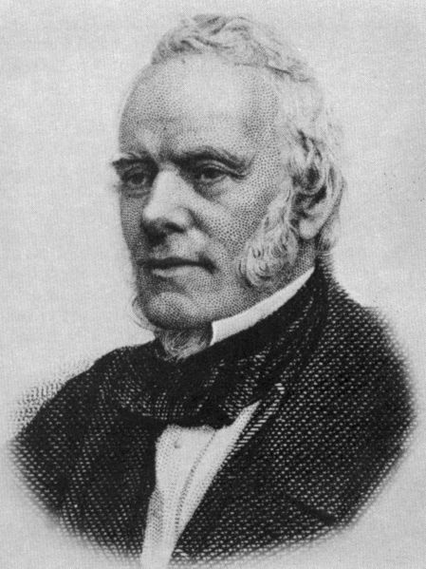
      - Angas had distributed millions of gospel tracts in his lifetime. Many of South Australia's founders were Christians. Such people as Robert Torrens who stated in a House of Commons speech In 1827 that "We are cooperating in the scheme of Providence and are the favoured Instrument In causing Christian civilization to cover the earth, as the waters cover the sea."
At that time one had to virtually be a lay preacher to be a director of the South Australia Company. Robert Gouger, the Colonial Secretary was a devout evangelical. Even E.G. Wakefield acknowledged that without him South Australia would not have been settled as early as it was. It was Gouger who wrote a "Sketch of Proposal for Colonizing Australia". He organised the first public meeting for the free settlement of the South Australian coast, attended by 2,500 people in a Christian Centre, Exeter Hall in London. Many others instrumental in the formation of S.A. were Christians such as Lt. Col. George Gawler who was determined to establish a Christian settlement: Sir George Grey, Capt John Hindmarsh, Charles Mann, David McLaren, Capt. Barker, Edward John Eyre and clergymen such as T.Q. Stow as well as Lord Glenelg of the Home Office.
Hebrews 11:32 says 'and what more shall I say? I do not have time to tell about Gideon. Barak, Samson, Jephthah. David, Samuel and the prophets who through faith conquered kingdoms, administered justice, and gained what was promised...." So also we could continue about many of the early pioneers. People such as Matthew Flinders; or Capt. John Molloy with his wife Georgiana, "The Madonna of the bush," who settled in Western Australia, and were prayed over prophetically by other Charismatic Irvingite Christians before coming to Australia. There was of course the remarkable Caroline Chisholm, who in six years settled eleven thousand people as servants and farmers in N.S.W.; the Moravian Missionary Latrobe family of Victoria. Ludwig Leichhardt, who explored much of Australia's north; and the Rev John Flynn, who founded the Flying Doctor Service and the Australian Inland Mission, whose Presbyterian Ministers were known as the boundary riders of the bush, and which was responsible for establishing communication through the inland by pedal wireless, giving a mantle of support and protection over inland Australia, the size of Western Europe.
Australia's first Prime Minister, Edmund Barton, and another Prime Minister, George Reid, were trained in public speaking and inspired to enter public life through the vision of a Christian minister, Dr Steel. Evangelical Christians have also been responsible for the creation of some of Australia' s foremost inventions. John Ridley, a devout Christian, created the labour saving stripper, and the famous "Sunshine" Harvester was invented by H.V. McKay, who named it in honour of the "Son". It was manufactured in what was to be the largest factory in Australia for many years. In recent times in Australia we find committed Christians involved in major areas of human endeavour such as in Government, Business, Education, Health, Entertainment, Sport & Welfare. Christians have also been at the very forefront of community awareness campaigns, and public movements active in preserving Australia's Constitutional heritage and democratic freedoms.
Thus we can see that Australia's discovery, settlement and growth can easily be explained in terms of God's intentions for our nation. He has used His men and women to lead in so many areas of development that even the most humanist historian could have difficulty explaining away the mass of evidence at which this article only hints.
Law and Parliament Common Law have been based on the Christian faith, exemplified by the statue of Jesus occupying the central place above the entrance to the Royal

Courts of Justice in London, 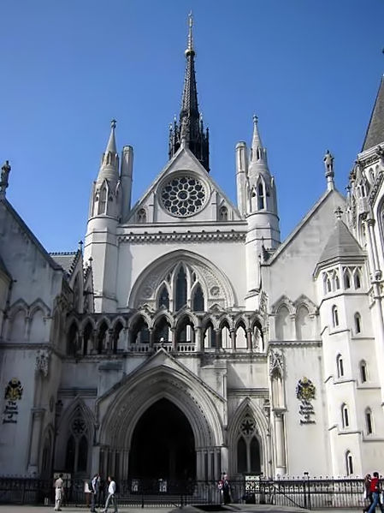 (pictured above the circle with Moses and Alfred the Great towards the side)
and by many statements by scholars such as one Chief Justice who declared: "Christianity is parcel of the Common Law of England and therefore to be protected by it. So whatever strikes at the very root of Christianity tends manifestly to the dissolution of civil government.²
If the past is misinterpreted then so is the significance of the future. It is important that we don't continue to be deceived by the secularization process which denies the sovereignty of God in history, and be like Esau who sold his birthright for a meal when Psalm 61:56 says: "You have given me the heritage of those who fear your name." Christians of Australia can rejoice in the contribution of our Christian forebears and confidently step out in faith aware of God's great intentions for our great island continent.
An enlarged picture of Jesus can be found here http://www.artandarchitecture.org.uk/images/conway/145ad2a2.html
For further information on our Christian Heritage visit www.chr.org.au

