The Queen and the Christian Connection
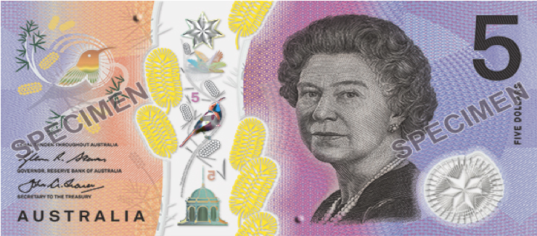
Did you know that Queen Elizabeth II had two ceremonies to mark the beginning of her public office?
The first was her coronation as Queen but the second was her ‘coronation’ as God’s servant. In this second untelevised ceremony, the Queen stood dressed in a simple white dress, devoid of decoration.
As she entered a place too sacred to be televised, Handel’s anthem ‘Zadok the Priest’ was sung and the symbols of the Queen’s status were removed; including, the crimson velvet robe, the diamond diadem and the coronation necklace.
The Archbishop anointed her with holy oil and poured it onto her hands and head, symbolic of the fact that she was being set apart as God’s servant; to love and serve her people with all her actions, heart and mind.
This moment in the Queen’s life was recorded by the Royal Biographer William Shawcross who wrote:
“It was the moment when the holy oil was applied to her, rather than her crowning with St Edward’s crown of solid gold, that was of supreme importance to the Queen. Indeed, it was the most solemn and important moment of her entire life.”

