**Missionary Gladys Staines Honoured for her Service to the Indian Community**



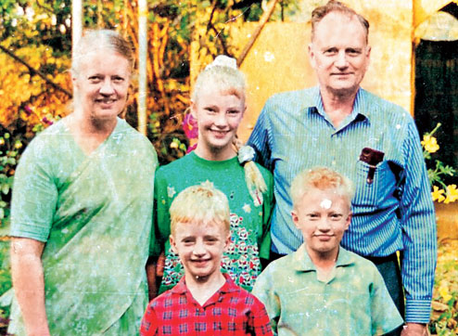

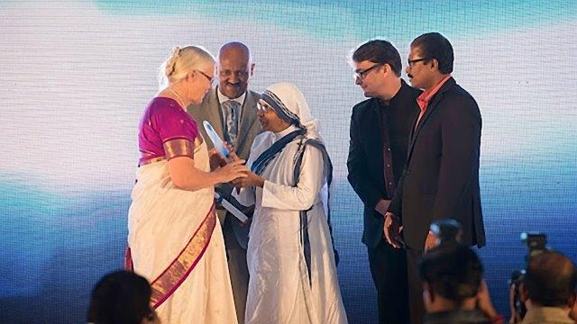

**GLADYS Staines from Queensland was honoured with the Indian-based Harmony Foundation's *Mother Theresa Memorial Award for Social Justice 2015* for her work in serving poor and leprosy affected peoples in India – almost 17 years after Gladys and her daughter Esther (then 13), at their home in Baripada in the Mayurbhanj district of Orissa, heard the tragic news that her missionary husband, Graham, and their two sons, Philip (10) and Timothy (6) had been deliberately burnt to death in their station wagon at the village of Monoharphur, 160k away. Graham had been attending the annual *Jungle Camp* (Christian Convention). Their attackers accused Graham of forcibly converting tribal Hindu people to Christianity. The killing triggered an outcry around the world, with then President K.R. Narayanan denouncing it as a ‘crime that belonged to the world’s inventory of black deeds’.**

**Many were impacted by the expression of forgiveness from Gladys even in her profound grief.**

**Graham and Gladys were serving with the Evangelical Missionary Society in Mayurbhanj (EMSM), founded in 1895 by Kate Allenby from Windsor Road Baptist Church in Qld. The work focussed on serving those affected by leprosy and other impoverished and outcast peoples; and on planting and supporting local churches. A succession of missionaries served the mission and, by the time of the deaths in January 1999, it comprised a Leprosy Home (with 70 residents) and farm, a Rehabilitation Community and farm (approx. ten families), two mission compounds and around 27 churches. In 2005 Gladys was awarded the prestigious *Padma Sri for Social Service Award* by the Government of India.**

**In granting the *Mother Theresa Memorial Award For Social Justice*, Dr Abraham Mathai of the Harmony Foundation advised Gladys, ‘We are pleased to highlight this year’s focus on women’s and children’s rights and access to affordable medical and health care services to those who are marginalized and destitute. Considering your work with leprosy patients in the remote tribal areas of Mayurbhanj, Orissa over the past 30 years, along with your tireless efforts to continue serving the medical and health care needs of the local community through the Graham Staines Memorial Hospital opened in 2004, it is Harmony Foundation’s great pleasure to invite you to grace this auspicious occasion to receive the prestigious Mother Teresa Memorial Award.’ The Award was conveyed at a ceremony in Mumbai on 22 November. ‘It's an honour for me, my husband and my entire family,’ she said, recalling that her first reaction after the tragic incident was whether she would be able to stay in India or need to return to Australia. ‘I thought, “I hope I don’t need to return to Australia. This place has been my home for 15 years.” I wanted to go on living there and continue the work. I’m so glad that I did,’ Gladys**

**told the *Mumbai Mirror*.**

**Gladys continued to live and serve in India until 2004, when she returned to Queensland. In a report on the award printed by *Asia News*, Gladys said, ‘I have never worked for awards, and was amazed to be chosen for this award. While I have not been living in India some time, I periodically visit and take great interest in the work for leprosy being carried out in Orissa. I thank God for His help in enabling me to carry out the work of caring for people with leprosy, even after my husband was killed’. Now living in Townsville, Gladys continues serving as the Honorary Secretary of EMSM. She has made several visits to support and advise on the development of the ministry in India. The 15 bed Graham Staines Memorial Hospital was opened in 2004, the Philip and Timothy Memorial Hostel for 40 boys in 2003 and the Kate Allenby Girl Child Care Centre/Hostel with seven girls in 2013.**

**Gladys is quick to say that such progress has much to do with the initiative, sacrifice and hard work of many others in India and through the generosity of many donors, especially in Australia. The church ministry continues to benefit from a partnership with the Indian Evangelical Mission, with a new agreement currently being drawn up. The medical work has benefited for services and drugs provided by The Leprosy Mission and the hospital with staff seconded from the large Christian Fellowship Hospital.**