Making note of our Historic Flying Doctor Service

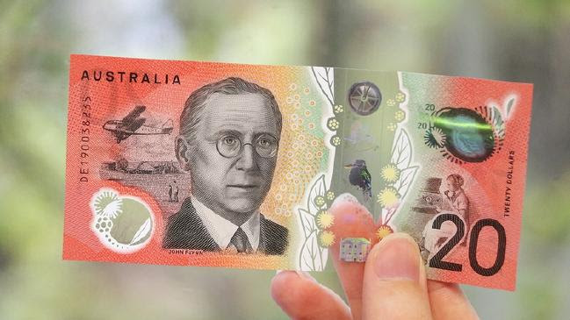
The Royal Flying Doctor Service was a regular visitor to The Veldt station 170km north of Broken Hill when it was home to Helen and Allan Barlow and their eight children, more than 70 years ago.
So it seems only fitting that a historic promotional image taken at the homestead in 1948 takes pride of place next to RFDS founder John Flynn on the new $20 note.
The photograph featuring a low-flying de Havilland biplane watched by two people was verified as the “real deal” by the Barlows’ daughter, Helen Bates. Now 81 years old, the Broken Hill resident was just 10 at the time but remembers the day very clearly.
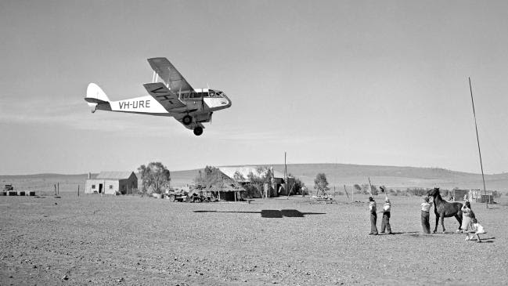
An RFDS plane outside Alice Springs in 1948. Picture: Australian News & Information Bureau / J. Fitzpatrick
“I wasn’t actually in the photo because I was a bit of a sook of a kid and I stayed in the house, making cups of tea for the men,” Mrs Bates explained.
“It was very clever, because it was taken as is.
“There was no photoshopping then and it took quite a few goes to get it right. Dad was worried it was going to clip an aerial.”
She noted the aircraft’s placement had been reversed on the new $20 bill so “it didn’t look like it was flying into Reverend Flynn’s ear”, and Helen’s mother, sister Judith and a horse were cut out of the picture.
“It’s still very exciting to see it there on the $20 note,” Mrs Bates said.
“The RFDS was a big part of our lives. I can remember all eight of us lining up to get immunised (by the flying doctor).”
Then there was the night one of her brothers cut his eye open while hammering a piece of steel, leaving another one to stitch him up with instructions from the flying doctor “over the transceiver”.
“Another brother had done an agricultural course so he got to do the stitching,” recalled Mrs Bates.
“The doctor talked him through the process over the transceiver — he was wonderful.”
Reserve Bank assistant governor Lindsay Boulton said the new banknote would be in circulation from next week, celebrating the enterprise and ingenuity of John Flynn and convict, entrepreneur and philanthropist Mary Reibey.
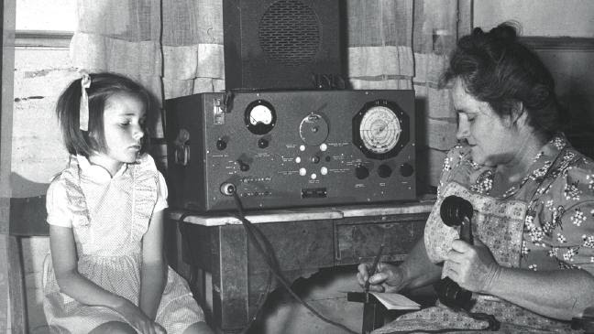
“The banknote includes a passage from Flynn’s book, The Bushman’s Companion,” Mr Boulton said.
“The passage is reproduced in microprint on the banknote and is one of a number of innovative security features to help protect the banknote from counterfeiting.”
The note also features three raised bumps along its long edges so blind and low-vision users can distinguish it from other denominations.
RFDS spokeswoman Lana Mitchell said they were delighted to again have Reverend Flynn on the note, along with the historic image from The Veldt station.
“Hopefully it might encourage people to consider donating $20 to the RFDS,” Ms Mitchell said.
Link

