**Field Marshall Montgomery**

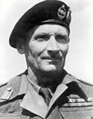

**As an infant watching Tasmanian soldiers depart for the Boer War, Bernard Law Montgomery told his mother he was going to be a soldier when he grew up.**

**Left for dead on the battlefield of Meteren during WW1 Captain Montgomery, not needing the grave already dug for him, went on to become the finest General in WW11, turning the tide against the previously invincible Rommel's German Axis forces in North Africa, with famous battles such as El Alamein and Tobruk.**

**Montgomery, now Field Marshal read two chapters of the Bible each day with devotions morning and evening, as observed by one journalist who wrote after the battle of El Alamein:**

**"This was total war, waged with more weight, power and concentration than the Nazi war machine ever had encountered and directed by a master of total war - a man who said his prayers in his desert tent night and morning and quoted the Bible to his troops to make them better fighters"**

**Montgomery's father had been a Bishop in Hobart at the turn of the 20th Century. His wife said this in a Bible Success band booklet written in 1945:**

**"I wonder how many of my readers have been brought up to learn a verse from the bible every day? I was brought up to do this and as a consequence know nearly all the Psalms and most of the New Testament by heart.**

**And I brought my children up to learn a verse from the Bible every morning before breakfast. It may be that Field Marshal Montgomery's knowledge and love of the Bible starts from the this fact. As is well known, the two books he carries with him are the Bible and Pilgrim's Progress.**

**England and America owe their greatness to the Bible. Let us pray that the Bible, God's Word to us, may again take its rightful place in our hearts and homes! I would urge upon all my readers to do your utmost to bring the Bible back to the nation. And the best way to do that is to begin in your own home and for you and your children to learn a verse of the Bible by heart each day"**

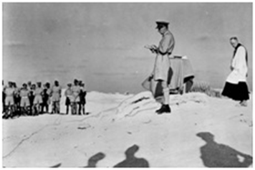

**MAY 16 1943 Montgomery Leads Prayers near front lines. Field Marshal Montgomery commenced prayer meetings when he arrived in Egypt. His father was a Bishop in Tasmania.**

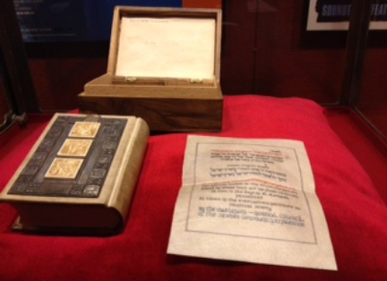

**The Montgomery Old Testament Bible with the message** **"Field Marshal Viscount Montgomery, GCB, DSO, the gallant leader of the victorious forces by whose hand God has placed salvation in Zion in the days of El Alamein presented in token of the everlasting gratitude of Palestine Jewry by the Vaad Leumi, General Council of the Jewish Community in Palestine".**

**Further reading:**

[[cid:part16.06070605.07060509@netwit.net.au](http://www.chr.org.au/documents.html) http://www.chr.org.au/documents.html](http://www.chr.org.au/documents.html)   
[[cid:part16.06070605.07060509@netwit.net.au](http://www.chr.org.au/feature-articles/Field-Marshal-Montgomery.html) http://www.chr.org.au/feature-articles/Field-Marshal-Montgomery.html](http://www.chr.org.au/feature-articles/Field-Marshal-Montgomery.html)