**Ramon Williams a hero of Australian Christian Media**

Press Service International for Christian Today Australia - Mark Tronson

If you read any published Australian Christian ‘news’ article since 1967, it has almost certainly been distributed by one of the greatest unsung heroes of the Australian Christian movement, the “AAP-equivalent” of Christian wire news, Ramon Williams, now aged in his eighties.

Over those years Ramon Williams has exercised a unique and important ministry in the proclamation of the Gospel of Jesus Christ, with his catch cry, “Telling others what others are doing for the Lord.”  
  
In 1959 the newly married Ramon and Dorothy arrived as missionaries in Indonesia with the Worldwide Evangelization Crusade (WEC). By 1965, their first three children were born. After triplets arrived in 1967 they concluded this overseas stint.  
  
Their audio-visual work for WEC grew and became an independent mission, now called ‘Worldwide Photos’, whose aim was to serve missionaries and Christian organisations; to enable them to better ‘show’ their work as well as ‘tell’ of it. This has helped many of them to raise increased interest and support.   
  
It all functions as a faith financed mission. Only a very few organisations or individuals make a contribution to this service.

His coverage of Cyclones Tracey (Darwin-1974), Eric and Nigel, (Fiji-1985); Namu (Solomons-1986), Uma (Vanuatu-1987) and Larry (North Queensland-2006) reported on churches, missions and welfare activities.

Ramon Williams’ photography is renowned, with pictures of such notables as Billy and Franklin Graham, Princess Diana, Prince Charles, Queen Elizabeth II, Malcolm Muggeridge, Mother Theresa, Mary Whitehouse, and many political leaders and musicians.  
  
Ramon’s effort has been Herculean, his great joy is to see that whatever he ‘distributes’ is published somewhere (newspapers, magazines, bulletins, online), in order that someone might read of the Lord’s work.   
  
His Christian media colleagues in 1987 quietly and unobtrusively recognised his remarkable contribution with the Australasian Religious Press Association's “Gutenberg Award”.   
  
The Lord constantly raises up ordinary people such as Ramon Williams who then engage in extraordinarily miraculous Kingdom endeavours for specific needs within the life of a nation’s Christian community.

**What is the photo/story covered he is most proud of?**

Cyclone Tracy (Darwin, December 25, 1974). I was there December 27, courtesy of an RAAF Hercules, stayed five days and reported (and photographed) every church’s damage and spent a day photographing the Red Cross activities, for a friend. I was able to talk Telecom into helping me make a phone call to 2CH on the Sunday (Indonesian Government experience came in handy — talking officials into things I needed) and reported on what had happened to every denomination’s church. Radio station 2CH re-played the five-minute report throughout the day and night.

[Commissioner Margarite
            Warren](http://sacredturf.typepad.com/.a/6a01538fa28a51970b01a510eee47e970c-pi)

*Darwin disaster: Salvation Army Commissioner Margarite Warren at the airport.*

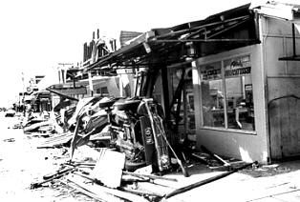

**Main Street, Darwin 1974. Four days in Darwin were spent checking, reporting and photographing every church as well as reporting by phone to a Sydney radio station what had happened   
to the churches.**

**What is the photo/story covered that was most difficult?**

The National Gathering in Canberra, 1988, when 30,000-40,000 Christians surrounded the new Parliament House, which was not including any prayers in the Opening Ceremony a week later. Besides photographing and reporting the event in Australia, I was the Australian reporter for the USA Radio Network and my phone report (from the motel) had to be 25 seconds! The first attempt was 27, so was refused! That report went across the USA and resulted in more feedback from there than from the secular media coverage here in Australia.

[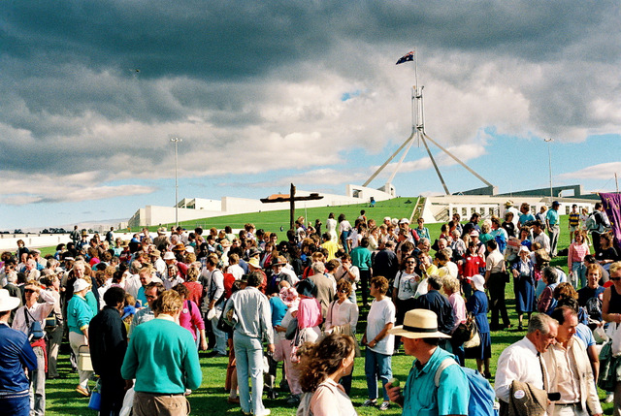](http://sacredturf.typepad.com/.a/6a01538fa28a51970b01a510eee98c970c-pi)

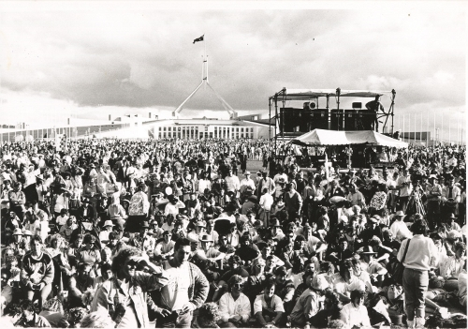

*Christians surround the new Parliament House, Canberra.*

**What keeps him going?**

The assurance the Lord had called me to do this work has kept me going. He has provided financially for the ministry and personal needs. Nobody else has provided for either, on a regular basis! Recently a support group decided to support mission work in Australia, whereas previously they only helped those overseas. As a result, I have been able to buy digital cameras.

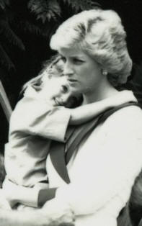

**Every Royal visit to St Andrew’s Anglican Cathedral, Sydney, has been photographed for the Anglican media. A visit by Princess Diana to a children’s center was photographed for Barnardos, with a classic photo taken of Her Highness holding a child – after the official media pack had left**